Biohub Rapid Response mNGS Protocols

The purpose of this document is to create a centralized location for protocols used in metagenomics sequencing (mNGS) for pathogen detection. These are guidelines for best practices and are subject to changes or modifications due to different sample types or experimental differences. Please contact the Rapid Response Team for additional questions or explanations.

For protocol revision history, please refer to the Document Revision History section at the end of this document.

Working on the bench:
- Before commencing work and after finishing your work, always wipe the workspace with RNAseZap/RNAseAway and 70% EtOH.
- Tie up long hair
- Wear a clean lab coat
- Change out gloves often
- All steps prior to PCR are performed in the Pre-PCR room (Room 4042) and all steps afterward are performed in the BSL1 general Post-PCR lab.
- Organize your workspace in a way that avoids hovering over clean tips/tubes with a used pipette
- Only have the necessary materials out for the protocol you are performing
- Only place your laptop in the mat indicated for laptops, avoid taking laptops into the Pre-PCR room, if possible
- Clean up space at the end of the day with 70% EtOH and disposing of trash.

Working in an RNAse free environment:
https://www.thermofisher.com/us/en/home/references/ambion-tech-support/nuclease-enzymes/tech-notes/how-to-maintain-an-rnase-free-lab.html

Workflow:
- Sample Collection, Storage, and Preparation
- Nucleic Acid Extractions
- Nucleic Acid Quality Control (QC)
- Illumina Library Preparation
  - RNA library preparation
  - DNA library preparation
- Library QC & Pooling
- iSeq loading

Appendix:
- Reagent catalog links and numbers
- Enrichment Methods
- DASH protocol
- Dual guide RNA Transcription for DASH and FLASH
- SPRI bead QC protocol
- Post-PCR Decision Tree
- ERCC aliquot SOP
- Secondary Library Amplification SOP
- Right Side SPRI Size selection
- Metagenomics protocol for nanopore ONT platforms
- TruSeq compatible mini adapters
- Document Revision History

1. Sample Collection, storage and preparation

Goal: To obtain a sample that will retain the integrity of nucleic acids.

Workflow:
- Collect samples using sterile techniques and minimizing environmental contamination, into a nuclease-free container.
- Store samples in DNA/RNA Shield if cold-chain is not reliable.
- Freeze samples at -80°C until ready to process.

Considerations:
- Nucleic acid degradation can come from many places (DNAses, RNAses, heat, freeze/thaws, metal ions, contaminating microbes). Flash freezing is the preferred choice (liquid nitrogen or ethanol & dry ice bath).
- RNA is more fragile than DNA
- Preserve samples by using nucleic acid stabilizers (i.e.: DNA/RNA shield, RNAlater)

Protocols by sample type: This section covers our recommendations for sample preparation required prior to nucleic acid purification (Section 2).

Stool:
- Scoop ~0.2g or 200uL of sample into a sterile collection tube. Add 400uL of 1x Zymo DNA/RNA Shield to completely submerge the sample and shake to mix. Alternatively, add directly to DNA/RNA lysis tubes which contain bashing beads and 1x shield (Zymo Cat. #R1103).
- Samples can be frozen at -80°C or proceed with homogenization.
- Add ZR Bashing beads (Zymo Cat. #S6012-50) to shield sample if not already in lysis tubes. Homogenize the sample using a high speed benchtop homogenizer. Typically, 1 min of vortexing followed by 1 min incubation on ice for a total of 3 cycles will thoroughly homogenize the sample.
- Spin the sample to pellet the cell debris. Transfer the supernatant to a new tube.
- Purify with one of the following: Zymo Pathogen Magbead, Zymo Quick DNA/RNA Fecal/Soil Microprep Kit.

Tissue/Vectors/Insects:
- Completely submerge the tissue sample (<10mg) or vectors into 1x Zymo DNA/RNA Shield. Attempt to break up the sample to allow the shield to penetrate. Alternatively add the tissue sample directly to DNA/RNA Shield lysis tubes which contain bashing beads (Zymo Cat. #R1105).
- Samples can be frozen at -80°C or proceed with homogenization.
- Add sterile 5mm ball bearings or ZR BashingBeads (Zymo Cat. #S6014-50) to the sample containing shield unless already in lysis tubes with beads. Homogenize the sample using a high speed benchtop homogenizer or vortexer. Typically 1 min of vortexing followed by a 1 min incubation on ice for a total of 3 rounds will completely homogenize the sample.
- Spin the sample to pellet the cell debris. Transfer the supernatant to a new tube.
- Purify with one of the following: Zymo Pathogen Magbead, Zymo Quick DNA/RNA Mini or Microprep kit.

Swabs:
- Add just enough 1x Zymo DNA/RNA Shield to completely submerge the swab & mix vigorously. Sterile 0.1-0.5mm beads (such as Zymo Bashing Beads https://www.zymoresearch.com/products/zr-bashingbead-lysis-tubes-0-1-0-5-mm) can be added to the sample and vortexed to aid in the dispersal of microbes from the swab into the shield solution.
- Supernatant from the swab sample or swab frozen in shield can be frozen at -80°C or proceed with extractions.
- Purify with one of the following: Zymo Pathogen Magbead, Zymo Quick DNA/RNA Microprep

Isolates:
- Using a sterile pipet tip, scoop a small portion of the bacterial or fungal isolate and mix directly into 1x Zymo DNA/RNA Shield. Vortex briefly. Alternatively add isolate sample directly to DNA/RNA lysis tubes which contain bashing beads and 1x shield (Zymo Cat. #R1103)
- Samples can be frozen at -80°C or proceed with homogenization.
- Add ZR Bashing beads (Zymo Cat. #S6012-50) to shield sample if not already in lysis tubes. Homogenize the sample using a high speed benchtop homogenizer. Typically 1 min of vortexing followed by 1 min incubation on ice for a total of 3 rounds will homogenize the sample thoroughly.
- Spin the sample to pellet the cell debris. Transfer the supernatant to a new tube.
- Purify with one of the following: Zymo Pathogen Magbeads, Zymo Fungal/Bacterial Zymobiomics DNA/RNA Miniprep

Urine:
- Collect urine in a sterile collection tube. Add 70uL of Zymo urine conditioning buffer (Zymo Cat. #D3061-1-8) for each 1mL of urine. Mix by inverting several times.
- Samples can be frozen at -80°C or proceed with extractions.
- Purify with one of the following: Zymo Pathogen MagBead, Zymo Quick DNA/RNA Microprep kit

Whole Blood:
- Suggested starting volume 25-50uL. Be aware that the blood will clot! Add 2 volumes of 2x DNA/RNA shield to the whole blood sample. Mix vigorously by vortexing.
- Samples can be frozen at -80°C or proceed with extractions.
- Perform a proteinase K treatment (8uL of 20mg/mL Proteinase K solution for every 400uL of sample in shield) and mix the sample until the sample is no longer clotting, incubate for 5-15 minutes at RT, mixing occasionally.
- Spin the sample to pellet the cell debris. Transfer the supernatant to a new tube.
- Purify with one of the following: Zymo Pathogen MagBead, Zymo Quick-DNA/RNA Blood tube kit, Zymo Quick DNA/RNA Microprep or Miniprep kit.

Plasma/Serum:
- Suggested starting volume >200uL. Add 1 volume 2x DNA/RNA shield to the plasma or serum sample. Mix by inverting several times.
- Samples can be frozen at -80°C or proceed with extractions.
- Perform a proteinase K treatment (4uL of 20mg/mL Proteinase K solution for every 400uL of sample in shield) and mix the sample. Incubate at RT for 5-10 min, mixing occasionally.
- Spin the sample to pellet the cell debris. Transfer the supernatant to a new tube.
- Purify with one of the following: Zymo Pathogen MagBead, Zymo Quick DNA/RNA Microprep kit

Saliva, tracheal aspirates, bronchial lavage:
- Suggested starting volume >100uL. Add 1 volume 2x DNA/RNA shield to the saliva, tracheal aspirates, or bronchial lavage sample. Mix by inverting several times.
- Samples can be frozen at -80°C or proceed with extractions.
- Purify with one of the following: Zymo Pathogen MagBead, Zymo Quick DNA/RNA Microprep kit

CSF:
Raw CSF, no preservative added
- Suggested starting volume of raw CSF: >200uL
- Ideally begin with raw, unfrozen specimen. If already frozen, remove CSF specimen (containing no preservative) from -80°C and thaw on ice
- Spin 100-200uL sample aliquot at 1500xg for 5min
- Save supernatant [sequence this sample] and save pellet [save for backup], in two different tubes
- Add DNA/RNA Shield
  - Supernatant sample: add 1 volume 2x DNA/RNA Shield to 1 volume supernatant
  - Pellet sample: add ~100-200uL 1x DNA/RNA Shield to the pellet
- Samples can be frozen at -80°C or proceed with extractions of the supernatant
- Purify with one of the following: Zymo Pathogen MagBead, Zymo Quick DNA/RNA Microprep kit

CSF in preservative such as DNA/RNA Shield
- Suggested starting volume of CSF-preservative mix: >400uL
- Remove CSF samples (containing preservative) from -80°C and thaw sample on ice
- Spin 200-400uL aliquot at 1500xg for 5min
- Save supernatant [sequence this sample] and save pellet [save for backup], in two different tubes
  - Add ~100uL 1x DNA/RNA Shield to the pellet
- Samples can be frozen at -80°C or proceed with extractions of the supernatant
- Purify with one of the following: Zymo Pathogen MagBead, Zymo Quick DNA/RNA Microprep kit

Sputum:
- Suggested collection volume > 1 mL. Beware that sputum is viscous and can be tricky to aliquot, so ideally collect a dedicated sample for mNGS.
- Add 1:1 volume of 2x DNA/RNA Shield immediately upon collection. One option is to use these Zymo Saliva/Sputum collection tubes. Another option is to pre-aliquot Shield into tubes, and pour it into the sputum sample immediately upon collection (Note: DNA/RNA Shield contains guanidinium salts and so needs to be handled carefully)
- Shake the tubes well to ensure Shield is well mixed with the sputum sample.
- Samples can be frozen at -80°C or proceed with extractions.
- In case samples are too viscous to pipet, consider digesting the sample to break down viscosity (e.g. using collagenase)
- Purify with one of the following: Zymo Pathogen MagBead, Zymo Quick DNA/RNA Microprep kit

2. Nucleic Acid Extractions

Goal: To extract high quality DNA and/or RNA

Workflow:
- Zymo kits (Quick-DNA/RNA kit, Pathogen MagBead, ZymoBiomics Kits)
- Qiagen kits (AllPrep, RNAeasy, QIAmp) or other commercial extraction kits (Promega, Biomerieux) also will work fine if Zymo kits are not available.

Considerations:
- Most commercial kits that are certified DNAse/RNAse free from Zymo or Qiagen are typically good enough for mNGS. We prefer Zymo kits because we’ve found that they have a better yield than the Qiagen kits.
- We typically use the Zymo Quick-DNA/RNA Microprep or Zymo Pathogen Magbead kits
- For whole blood, using the general kits (like Microprep or Pathogen Magbead), samples must be pre-treated, see vendor protocol.
- For plasma/sera, perform a proteinase K treatment to avoid clogging columns

Protocols:
- For RNA/DNA combined extractions:
  - Zymo Quick-DNA/RNA Microprep Plus kit (column based): best for low concentration samples
  - Zymo Quick-DNA/RNA Miniprep Plus kit (column based): best for high concentration samples
  - Zymo Quick-DNA/RNA Pathogen MagBead kit (bead based): best to do many samples simultaneously, must have magnetic stand that can hold 1.5mL tubes or 96 well magnetic stand.
  - Zymobiomics DNA/RNA Miniprep kit (column based): good for microbiome samples for the most even lysis of microbes, microcentrifuge and homogenizer required
  - Qiagen AllPrep DNA/RNA Micro kit (column based): best for low concentration samples
  - Qiagen AllPrep DNA/RNA Mini kit (column based): best for high concentration samples

- For DNA extractions only:
  - Zymo Quick-DNA Fecal/Soil kits (column and bead based kits): Both column and bead based kits depending on the availability of a microcentrifuge or magnetic stands. Fecal and soil samples typically extract poorly in non-specific kits (i.e.: Zymo Quick-DNA/RNA Micro or Mini prep kit) because of inhibitors in the samples.
  - Zymo Quick-DNA Fungal/Bacterial kits (column based): for isolates/colonies
  - Zymo Quick-DNA Urine Kit (column based)

- For RNA extractions only:
  - Zymo Quick-RNA Microprep Plus kit (column based): best for low concentration samples.
  - Zymo Quick-RNA Miniprep Plus kit (column based): best for high concentration samples
  - Zymo Quick-RNA Fecal/Soil Microbe kit (column based)
  - Zymo Quick-RNA Fungal Bacterial kit (column based): for isolates/colonies
  - Qiagen RNeasy mini kit (column based)

For acquiring purified RNA from a combined DNA/RNA extraction:

Using Qiagen DNAse I:

Reagent | 87.5 µL sample | 20 µL sample
Reagent | vol stock (µL) | vol stock (µL)
TNA sample (bring up to this volume with nuclease-free water) | 87.5 | 20
RDD Buffer | 10 | 2.29
DNase I | 2.5 | 0.57
Total volume | 100 | 22.86

Incubate the sample at room temperature for 30 minutes

Cleanup the DNAse digestion prior to Nucleic Acid QC and Library preparation with a 2.0x ratio of SPRI:

SPRI Bead Clean-up:
*allow beads to sit in RT for 30 mins prior. Make 80% ethanol fresh each day.
- Use SPRI Beads 2.0x ratio of beads-to-total volume of sample. Prep 80% EtOH.
- Add 2x volume of room temperature beads to sample. Mix well by pipetting gently.
- Pulse spin the tubes, but be sure not to spin down beads. Incubate for a minimum of 5 mins at room temperature.
- Place samples on magnetic rack, and incubate for 5 mins on the rack.
- Remove supernatant.
- Add 200uL of 80% EtOH to samples while on the magnetic rack. Incubate at room temperature for 30s then remove the supernatant.
- Repeat EtOH wash step for a total of 2 washes.
- Air dry the beads for up to 5 mins while on the magnetic rack. Watch beads carefully throughout this incubation to avoid overdrying; smaller bead pellets dry faster.
- Remove tube from magnetic rack. Elute DNA from beads into 12uL (or the volume of your choosing) of nuclease free water.
- Vortex or pipette to mix well. Spin tubes and incubate for a minimum of 2 mins at room temperature off the magnetic rack.
- Place on magnetic rack until solution is clear ~ 5 mins.
- Remove 10uL of the supernatant and transfer to a clean nuclease free PCR tube.

Using Zymo DNase I set:

Reagent | 20 µL sample
Reagent | vol stock (µL)
TNA sample (bring up to this volume with nuclease-free water) | 20
DNA Digestion Buffer | 2.50
DNase I* (reconstituted; 1 U/µL) | 2.50
Master Mix volume | 5.00
Total volume | 25.00

* Reconstitute lyophilized Zymo DNase I (#E1009-A) nuclease-free water and mix

Incubate the sample at room temperature for 15 minutes

Cleanup the DNAse digestion prior to Nucleic Acid QC and Library preparation with a 2.0x ratio of SPRI (see protocol above)

3. Nucleic Acid Quality Control (QC)

Goal: Quantify and Qualitatively assess the amount and integrity of input nucleic acids prior to starting library preparation

Workflow: Assess the nucleic acid concentration and quality before library preparation.

Considerations:
- Quantification can be performed using a Qubit, Nanodrop, Agilent Bioanalyzer, Agilent Tapestation, Agilent Fragment Analyzer, Qiagen Qiaxcel. Qubit results are much highly preferred over the nanodrop. Capillary systems (bioanalyzer, tapestation, qiaxcel, etc) are preferred over the qubit.
- Quality control can be performed using any of the capillary electrophoresis systems or, if you have high quantities of sample input, a standard agarose gel can also be used. The aim of quality control is to know the integrity of either RNA (by proxy rRNA bands) or DNA (high molecular weight bands) depending on whether you have extracted either DNA or RNA.

Protocol:
Follow the manufacturer’s protocol specific to either RNA or DNA.
RNA quantification by Qubit HS RNA kit
DNA quantification by Qubit HS DNA kit
RNA quantification and quality control Agilent RNA Pico Bioanalyzer protocol
DNA quantification and quality control Agilent High Sensitivity Bioanalyzer protocol, Qiagen Qiaxcel

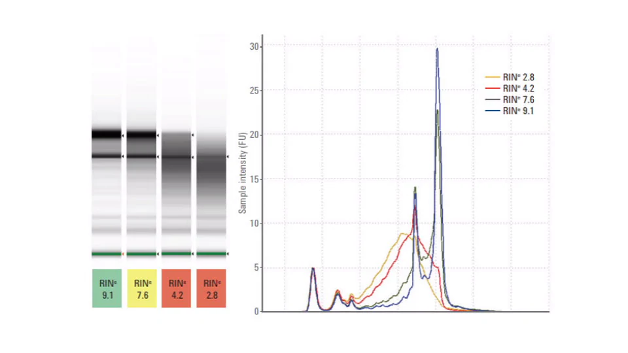
Quality control expected results:
RNA: This figure shows the RNA quality measured using the Tapestation system. As the quality decreases, the 2 rRNA bands will degrade and the RIN (RNA Integrity Number) will also decrease. This number will determine the duration of fragmentation in the RNA library prep protocol.

Suggested fragmentation times according to RIN score based on previous experiences. We still perform a short fragmentation to allow the ERCC spike-ins to fragment.

RIN | Fragmentation time
0-3 | 2 min
4-6 | 8 min
7-10 | 12-15 min

If you do not have access to a capillary electrophoresis system, make the best assessment of the RNA quality based on the following criteria: Was the sample stored immediately in DNA/RNA shield or flash frozen in -80°C immediately after collection and never freeze/thawed? If yes, fragment for 12-15 minutes. If no, reduce the fragmentation time to 2-8 minutes depending on how long the sample was out before entering the cold chain and if the sample was freeze/thawed multiple times. Note that plasma and CSF tend to be more susceptible to degradation compared to samples with higher microbial abundance such as nasal swabs.

It is important to optimize fragmentation time for a particular sample set and lab conditions. See what initial libraries look like and adjust fragmentation time for subsequent runs based on the observed size distribution.
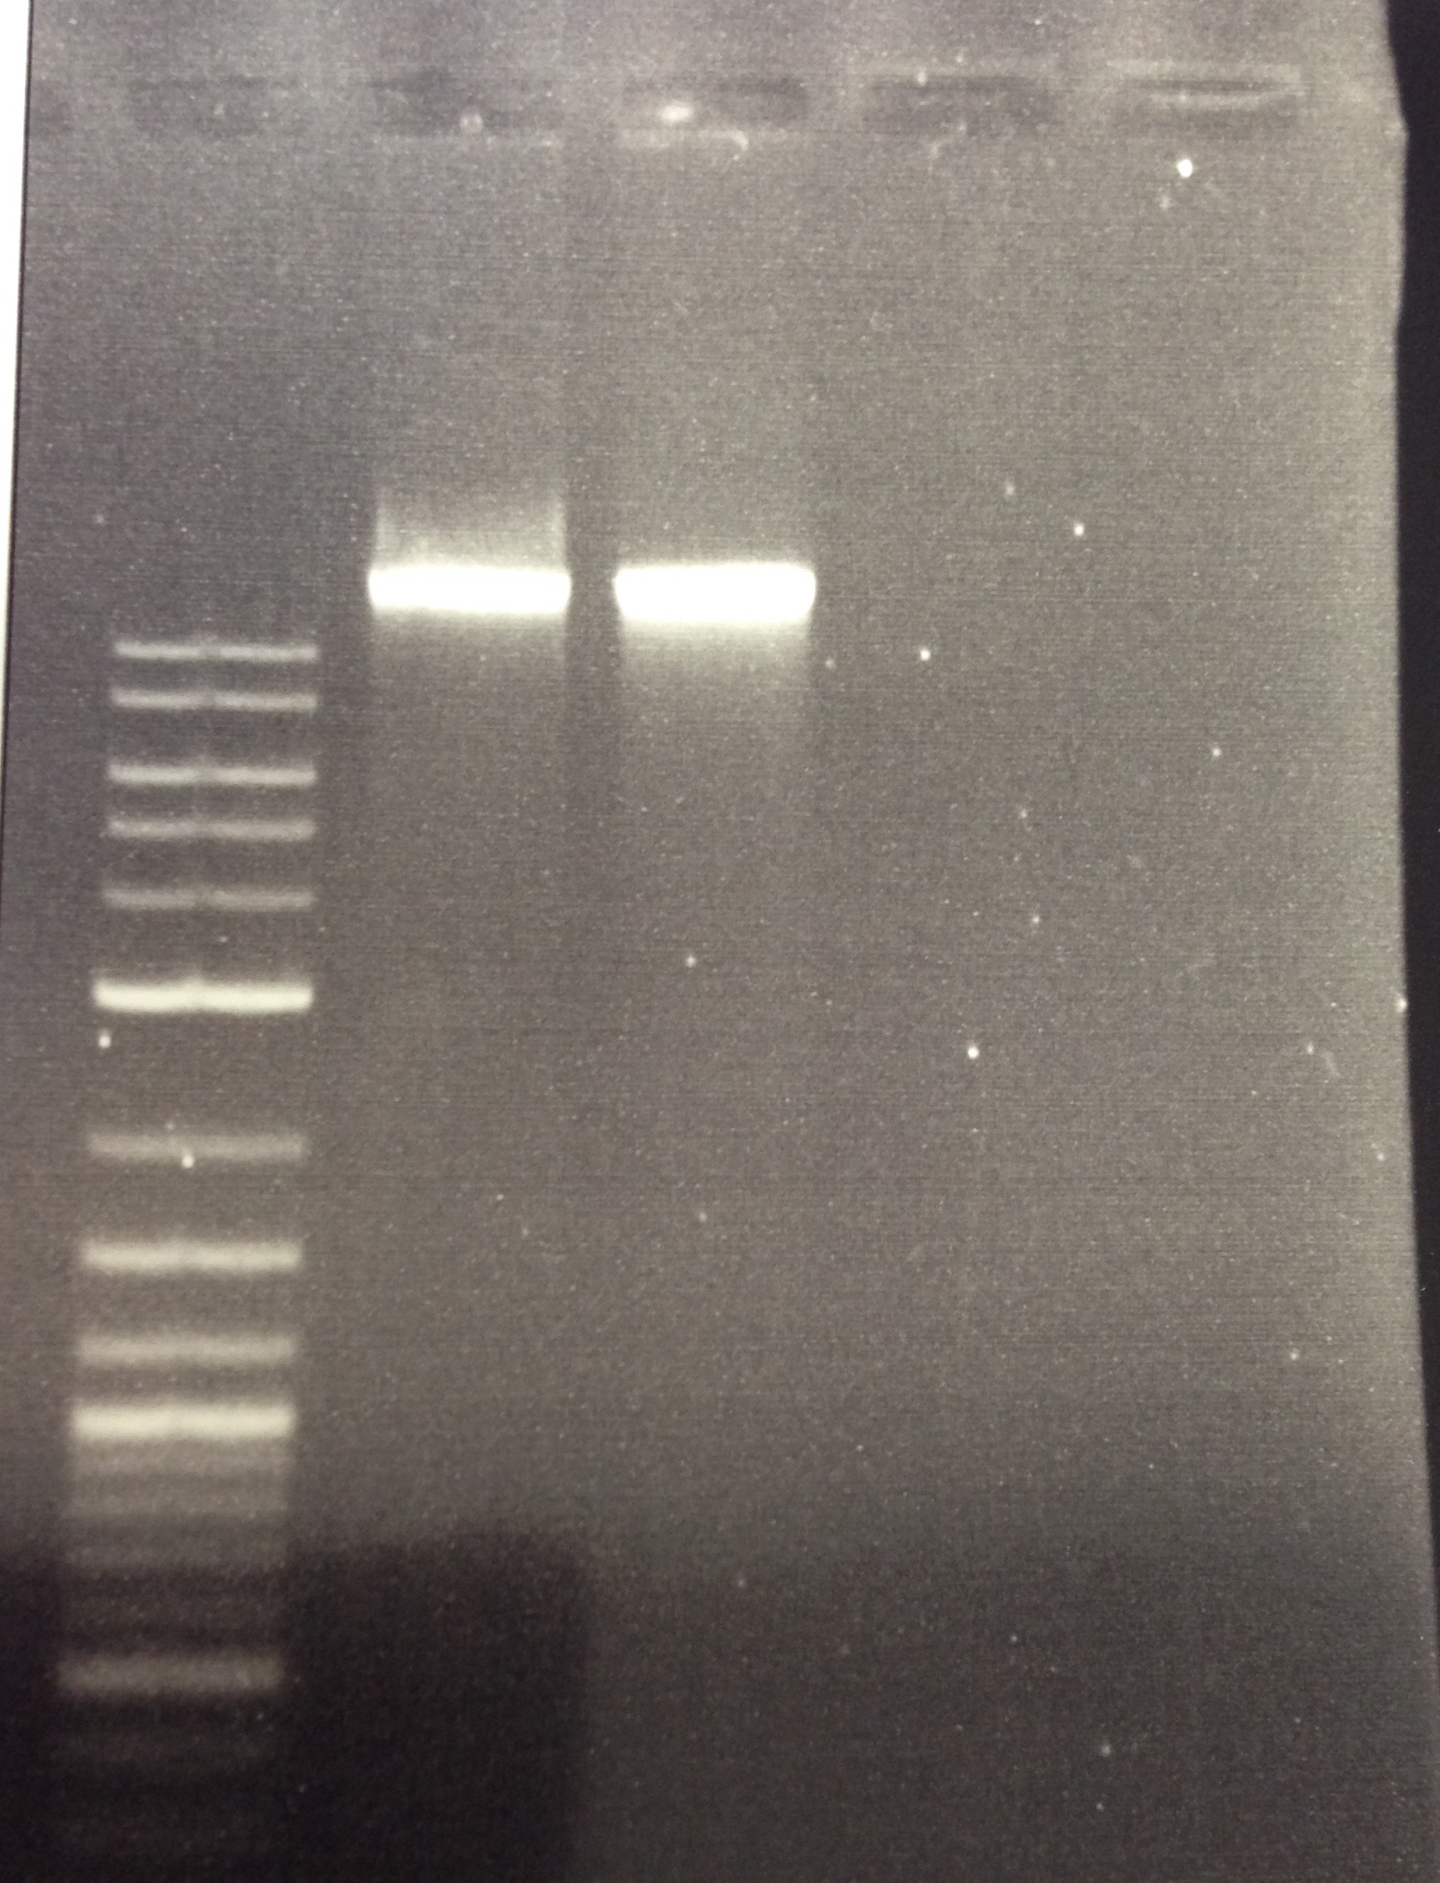
DNA: We expect high molecular weight bands for high quality DNA extractions which indicates that the samples weren’t sheared prior to the start of library preparation. Using a standard agarose gel or any of the capillary electrophoresis system, you will see the bands migrate slow and typically much higher than the larged band of a DNA ladder. For the NEB FS Kit, we fragment anywhere from 5-15 minutes depending on the assessed quality. For very large fragments as shown in this gel, 15 minutes of fragmentation is suggested and reducing as the quality reduces.

4a. Illumina Library Preparation - RNA Libraries

There are many commercially available library preparation kits, which fall into two main workflows: ligation and tagmentation. Below we include detailed methods for using the NEBNext Ultra II kit (ligation-based) with minor adaptations.

Many commercially available library preparation kits may be suitable for metagenomic libraries. If trying another library preparation kit, we recommend the following adaptations:
- Addition of ERCCs at the start of library preparation (internal control)
- Addition of Qiagen FastSelect to reduce host rRNA
- Use of truncated Mini Adapters at 3uM (see Appendix K, for ligation-based kits)
- Reduction of reaction volume to ½ or ¼ of prescribed volumes (for cost-saving)

Considerations:
- All steps to be done under a sterile clean hood until NEB PCR ENRICHMENT STEP; then everything can be done on the bench.
- Reactions should be done in sterile RNAse/ DNAse/ DNA-free tubes.

Protocol: These protocols are an adaptation of the NEBNext Ultra II RNA Library Preparation (non-directional) Protocol.

Workflow: RNA Fragmentation + Priming, first strand cDNA synthesis, second strand cDNA synthesis, SPRI clean-up, End Prep, Adapter Ligation, SPRI clean-up + size selection, USER + Barcoding PCR, SPRI clean-up + size selection.

- RNA Fragmentation + Priming: Mix the following thoroughly by pipetting up and down. See ERCC SOP in Appendix G for making aliquots.
 | 1 rxn | 0.5 rxn | _ x rxn
Reagent | vol stock (uL) | vol stock (uL) | vol stock (uL)
RNA (sample) (10ng – 100ng total) | 3.5 | 1.75 | 1.75
25pg ERCC Spike-in (50pg/uL stock) | 0.5 | 0.25
(pink) First SS Reaction Buffer 5x | 4 | 2
(pink) Random Primers | 1 | 0.5
*QIAseq FastSelect (1:10) rRNA | 1 | 0.5
Total volume | 10 | 5
 | uL/rxn | uL/rxn | Add 3.25uL mix to RNA sample
** FastSelect is designed for removing human rRNA, omit this reagent if not using human derived samples and only incubate at 94°C and then directly to 4°C (omit ramping down steps).
Thermocycler (heated lid set to 105ºC):
· 4 min* at 94°C * Adjust fragmentation time (94°C) according to RNA input amount and quality
· 2 min 75C
· 2 min 70C
· 2 min 65C
· 2 min 60C
· 2 min 55C
· 5 min 37C
· 5 min 25C
· Hold 4°C

- First Strand Synthesis: Mix the following by pipetting up and down.

 | 1 rxn | 0.5 rxn | __ x rxn
Reagent | vol stock (uL) | vol stock (uL) | vol stock (uL)
Fragmented & primed RNA | 10 | 5 | 5 each
Nuclease-free water | 8 | 4
(pink) NEBNext First Strand Synthesis Enzyme Mix | 2 | 1
Total volume | 20 | 10
 | uL/rxn | uL/rxn | Add 5uL mix to frag/primed RNA
Thermocycler (heated lid set to 105ºC):
· 10 mins at 25°C
· 15 mins at 42°C
· 15 mins at 70°C
· Hold at 4ºC

- Second Strand Synthesis:
 | 1 rxn | 0.5 rxn | __ x rxn
Reagent | vol stock (uL) | vol stock (uL) | vol stock (uL)
First strand synthesized DNA | 20 | 10 | 10 each
(orange) 2nd SS Reaction buffer (10X) | 8 | 4
(orange) 2nd SS enzyme mix | 4 | 2
Nuclease-free water | 48 | 24
Total volume | 80 | 40
 | uL/rxn | uL/rxn | Add 30 uL mix to ss-cDNA

Thermocycler (heated lid off):
· 1 hour at 16ºC
· Hold at 4°C

- SPRI Bead Clean-up:
*allow beads to sit in RT for 30 mins prior
- Use SPRI Beads 1.8x ratio of beads-to-total volume of sample. Prep 80% EtOH.
- Add 144uL (half reaction: 72uL) of room temperature beads to 2nd Strand Synthesis Rxn. Mix well by pipetting gently.
- Pulse spin the tubes, but be sure not to spin down beads. Incubate for a minimum of 5 mins at room temperature.
- Place samples on magnetic rack, and incubate for 5 mins on the rack.
- Remove supernatant.
- Add 200uL of 80% EtOH to samples while on the magnetic rack. Incubate at room temperature for 30s then remove the supernatant.
- Repeat EtOH wash step for a total of 2 washes.
- Air dry the beads for up to 5 mins while on the magnetic rack. Watch beads carefully throughout this incubation to avoid overdrying; smaller bead pellets dry faster.
- Remove tube from magnetic rack. Elute DNA from beads into 53uL (half reaction: 28uL) of 0.1x TE Buffer, 10mM Tris-HCl, or Nuclease free water.
- Vortex or pipette to mix well. Spin tubes and incubate for a minimum of 2 mins at room temperature off the magnetic rack.
- Place on magnetic rack until solution is clear ~ 5 mins.
- Remove 50uL (half reaction: 25uL) of the supernatant and transfer to a clean nuclease free PCR tube.
**Checkpoint: Samples can be stored frozen at -20 °C and library prep resumed the next day.

- End Prep of cDNA Library: Mix all the following by pipetting up and down.

 | 1 rxn | 0.5 rxn | __ x rxn
Reagent | vol stock (uL) | vol stock (uL) | vol stock (uL)
Purified ds-cDNA | 50 | 25 | 25 each
(green) Ultra II End Prep reaction buffer (8.6x) | 7 | 3.5
(green) Ultra II End Prep enzyme mix | 3 | 1.5
Total volume | 60 | 30
 | uL/rxn | uL/rxn | Add 5uL mix to ds-cDNA

Thermocycler (heated lid set to 105ºC):
· 30 mins at 20ºC
· 30 mins at 65ºC
· Hold at 4ºC

- Mini Adapter Ligation:
- Note: This protocol uses TruSeq compatible mini adaptors that are ordered separately from IDT. These adapters work better (far less adapter dimers) compared to the NEB adapter.
- See Appendix K for more information on ordering and diluting these mini adapters
- Add adaptor separately after ligation master mix and ligation enhancer to avoid adaptor dimers.
 | 1 rxn | 0.5 rxn | __ x rxn
Reagent | vol stock (uL) | vol stock (uL) | vol stock (uL)
End Prep reaction mixture | 60 | 30 | 30 each
(red) NEBNext Ultra II ligation master mix | 30 | 15
(red) NEBNext ligation enhancer | 1 | 0.5
Pre-annealed Mini adapter (3µM) | 2.5 | 1.25 | ** do not premix
Total volume | 93.5 | 46.75
 | uL/rxn | uL/rxn | Add 15.5 uL MM +LE to end prep rxn mixture, then add 1.25uL adaptor to the mix

Thermocycler (heated lid off):
· 15 mins at 20ºC with heated lid off
· Proceed immediately to Bead Purification.

- SPRI Bead Clean-up and size selection:
*allow beads to sit in RT for 30 mins prior
- Use SPRI bead 0.9x ratio of beads-to-total volume of sample. Prep 80% EtOH.
- Add 87uL (half reaction: 43uL) of room temperature beads (0.9x) to Adaptor Ligation reaction (~95 or 47uL). Mix well.
- Pulse spin the tubes, but be sure not to spin down beads. Incubate for a minimum of 5 mins at room temperature.
- Place samples on magnetic rack, and incubate for 5 mins on the rack.
- Remove supernatant.
- Add 200uL of 80% EtOH to samples while on the magnetic rack. Incubate at room temperature for 30s then remove the supernatant.
- Repeat EtOH wash step for a total of 2 washes.
- Air dry the beads for up to 5 mins while on the magnetic rack. Watch beads carefully throughout this incubation to avoid overdrying; smaller bead pellets dry faster.
- Remove tube from magnetic rack. Elute DNA from beads into 17uL (half reaction: 9uL) of 0.1x TE Buffer, 10mM Tris-HCl, or Nuclease free water.
- Vortex or pipette to mix well. Spin tubes and incubate for a minimum of 2 mins at room temperature off the magnetic rack.
- Place on magnetic rack until solution is clear ~ 5 mins.
- Remove 15uL (half reaction: 7.5uL) of the supernatant and transfer to a clean nuclease free PCR tube.
**Checkpoint: Samples can be stored frozen at -20 °C and library prep resumed the next day.
- Barcoding PCR with mini adapters:
Mix the following components by pipetting up and down.

 |  | 1 rxn | 0.5 rxn | __ x rxn
Reagent |  | vol stock (ul) | vol stock (ul) | vol stock (ul)
Purified, adaptor-ligated cDNA |  | 15 | 7.5 | 7.5 each
(blue) NEBNext Ultra II Q5 master mix |  | 25 | 12.5
5uM i7 barcoded primer (NEB index primer/TruSeq/or similar) | 5uL | 10 | 5 | 5 ul unique to each sample
5uM i5 barcoded primer (NEB Universal primer/TruSeq/or similar) | 5uL | (premixed)* | (premixed)*
Total volume |  | 50 | 25
 |  | ul/rxn | ul/rxn | Add 14 uL mix + 5uL of primers to adaptor-ligated cDNA

* Biohub orders their own Truseq primers from IDT. Alternatively, order NEB or Truseq index primers. (Cat: NEB E7335, E7500, E7710, E7730 when pooling <24 samples, Cat: NEB E6440 when pooling >24 samples, Illumina PE-121-1003). USER enzyme is only required if using the NEB Adapter.
Thermocycler (heated lid at 105ºC): | Cycles
37 °C for 15 mins | 1
98 °C for 30s | 1
98 °C for 10s | 6-19**
65 °C for 75s | 6-19**
65 °C for 5 mins | 1
Hold at 4 °C
** PCR cycles are dependent on the input RNA. For libraries with <5ng input, perform 15-19 cycles of PCR. For 5-20ng input, perform 10-14 cycles of PCR. For >20ng input, perform 6-8 cycles of PCR. PCR cycles can also be informed based on the sample type. For low microbial abundance samples (plasma, CSF), perform a higher number of cycles. For high microbial abundance samples, perform fewer cycles.
- SPRI clean-up and size selection
*allow beads to sit in RT for 30 mins prior
- Use SPRI Beads 0.8x ratio of beads-to-total volume of sample. Prep 80% EtOH.
- Add 43uL (half reaction: 22uL) of room temperature Ampure Beads (0.8x) to barcoded DNA (~53uL or 27uL). Mix well.
- Pulse spin the tubes, but be sure not to spin down beads. Incubate for a minimum of 5 mins at room temperature.
- Place samples on magnetic rack, and incubate for 5 mins on the rack.
- Remove supernatant.
- Add 200uL of 80% EtOH to samples while on the magnetic rack. Incubate at room temperature for 30s then remove the supernatant.
- Repeat EtOH wash step for a total of 2 washes.
- Air dry the beads for up to 5 mins while on the magnetic rack. Watch beads carefully throughout this incubation to avoid overdrying; smaller bead pellets dry faster.
- Remove tube from magnetic rack. Elute DNA from beads into 23uL of 0.1x TE Buffer, 10mMTris-HCL, or Nuclease free water.
- Vortex or pipette to mix well. Spin tubes and incubate for a minimum of 2 mins at room temperature off the magnetic rack.
- Place on magnetic rack until solution is clear ~ 5 mins.
- Remove 20uL of the supernatant and transfer to a clean nuclease free PCR tube.
** Checkpoint: Libraries are complete, samples can be stored frozen at -20 °C until ready for quantification and pooling

4b. Illumina Library Preparation - DNA Libraries

Workflow: Fragmentation/End Prep, Ligation, SPRI Clean-up + size selection, USER + Barcoding PCR, SPRI Clean-up + size selection.

Considerations:
- All steps to be done under a sterile clean hood until NEB PCR ENRICHMENT STEP; then everything can be done on the bench.
- Reactions should be done in sterile RNAse/ DNAse/ DNA -free tubes

Protocol:
This protocol is an adaptation of the NEB Next Ultra II FS DNA Library prep kit: https://www.neb.com/products/e7805-nebnext-ultra-ii-fs-dna-library-prep-kit-for-illumina#Product%20Information

- Fragmentation/End Prep:
 | 1x rxn | 0.5x rxn | _ x rxn
DNA (10-100ng) | 10-100ng | 5-50ng | Variable, 5-50ng for a half reaction
Water | ______ uL  Up to 26 ul with the DNA sample | _________ uL  Up to 13 ul with the DNA sample | _____ uL  Up to 13 ul with the DNA sample
(yellow) NEBNext Ultra II FS Reaction Buffer | 7 μl | 3.5 μl
(yellow) NEBNext Ultra II FS Enzyme Mix | 2 μl | 1 μl
Total Volume | 35 μl | 17.5 μl

In a Thermocycler, with the heated lid set to 105°C, run the following program:
10 min @ 37°C ****look at NEB protocol if sample is degraded, reduce fragmentation time
30 min @ 65°C
Hold @ 4°C
- Mini Adaptor Ligation:
- Note: This protocol uses TruSeq-compatible mini adaptors that are ordered separately from IDT. These adapters work better (far less adapter dimers) compared to the NEB adapter.
- See Appendix K for more information on ordering and diluting these mini adapters
- Add adaptor separately after ligation master mix and ligation enhancer to avoid adaptor dimers.
 | 1x rxn | 0.5x rxn | _ x rxn
FS Reaction Mixture | 35 uL | 17.5 µl | 17.5 uL each
(red) NEBNext Ultra II Ligation Master Mix* | 30 uL | 15 µl
(red) NEBNext Ligation Enhancer* | 1 uL | 0.5 µl
Pre-annealed Mini adapter (3µM) | 2.5 uL | 1.25 µl | Add 1.25 µl to each sample individually
Total Volume | 68.5 uL | 34.25 µl | Add 15.5 µl of the master mix (MM+LE) then add adaptor to each sample.

- Incubate at 20°C for 15 minutes in a thermocycler with the heated lid off.

- SPRI Bead Clean-up and size selection:
*allow beads to sit in RT for 30 mins prior
- Use SPRI bead 0.9x ratio of beads-to-total volume of sample. Prep 80% EtOH.
- Add 61uL (half reaction: 30.8uL) of room temperature beads (0.9x) to Adaptor Ligation reaction. Mix well.
- Pulse spin the tubes, but be sure not to spin down beads. Incubate for a minimum of 5 mins at room temperature.
- Place samples on magnetic rack, and incubate for 5 mins on the rack.
- Remove supernatant.
- Add 200uL of 80% EtOH to samples while on the magnetic rack. Incubate at room temperature for 30s then remove the supernatant.
- Repeat EtOH wash step for a total of 2 washes.
- Air dry the beads for up to 5 mins while on the magnetic rack. Watch beads carefully throughout this incubation to avoid overdrying; smaller bead pellets dry faster.
- Remove tube from magnetic rack. Elute DNA from beads into 17uL (half reaction: 9uL) of 0.1x TE Buffer, 10mM Tris-HCl, or Nuclease free water.
- Vortex or pipette to mix well. Spin tubes and incubate for a minimum of 2 mins at room temperature off the magnetic rack.
- Place on magnetic rack until solution is clear ~ 5 mins.
- Remove 15uL (half reaction: 7.5uL) of the supernatant and transfer to a clean nuclease free PCR tube.
**Checkpoint: Samples can be stored frozen at -20 °C and library prep resumed the next day.

- Barcoding PCR with mini adapters:

 |  | 1 rxn | 0.5 rxn | __ x rxn
Reagent |  | vol stock (ul) | vol stock (ul) | vol stock (ul)
Purified, adaptor-ligated cDNA |  | 15 | 7.5 | 7.5 each
(blue) NEBNext Ultra II Q5 master mix |  | 25 | 12.5
5uM i7 barcoded primer (NEB index primer/TruSeq/or similar) | 5uL | 10 | 5 | 5 ul unique to each sample
5uM i5 barcoded primer (NEB Universal primer/TruSeq/or similar) | 5uL | (premixed)* | (premixed)*
Total volume |  | 50 | 25
 |  | ul/rxn | ul/rxn | Add 14 uL mix + 5uL of primers to adaptor-ligated cDNA

* Biohub orders their own Truseq primers from IDT. Alternatively, order NEB or Truseq index primers. (Cat: NEB E7335, E7500, E7710, E7730 when pooling <24 samples, Cat: NEB E6440 when pooling >24 samples, Illumina PE-121-1003 ). USER enzyme is only required if using the NEB Adapter.

Thermocycler (heated lid at 105ºC): | Cycles
37 °C for 15 mins | 1
98 °C for 30s | 1
98 °C for 10s | 6-19**
65 °C for 75s | 6-19**
65 °C for 5 mins | 1
Hold at 4 °C

** PCR cycles are dependent on the input DNA. For libraries with <5ng input, perform 15-19 cycles of PCR. For 5-20ng input, perform 10-14 cycles of PCR. For >20ng input, perform 6-8 cycles of PCR. PCR cycles can also be informed based on the sample type. For low microbial abundance samples (plasma, CSF), perform a higher number of cycles. For high microbial abundance samples, perform fewer cycles.

- SPRI clean-up and size selection:
*allow beads to sit in RT for 30 mins prior
- Use SPRI Beads 0.8x ratio of beads-to-total volume of sample. Prep 80% EtOH.
- Add 43uL (half reaction: 22uL) of room temperature Ampure Beads (0.8x) to barcoded DNA (~53uL or 27uL). Mix well.
- Pulse spin the tubes, but be sure not to spin down beads. Incubate for a minimum of 5 mins at room temperature.
- Place samples on magnetic rack, and incubate for 5 mins on the rack.
- Remove supernatant.
- Add 200uL of 80% EtOH to samples while on the magnetic rack. Incubate at room temperature for 30s then remove the supernatant.
- Repeat EtOH wash step for a total of 2 washes.
- Air dry the beads for up to 5 mins while on the magnetic rack. Watch beads carefully throughout this incubation to avoid overdrying; smaller bead pellets dry faster.
- Remove tube from magnetic rack. Elute DNA from beads into 23uL of 0.1x TE Buffer, 10mMTris-HCL, or Nuclease free water.
- Vortex or pipette to mix well. Spin tubes and incubate for a minimum of 2 mins at room temperature off the magnetic rack.
- Place on magnetic rack until solution is clear ~ 5 mins.
- Remove 20uL of the supernatant and transfer to a clean nuclease free PCR tube.

5. Library QC & Pooling

Goal: Determine the quality of the finished libraries, pool libraries and quantify the final pooled libraries

Workflow: High sensitivity DNA Qubit, Tapestation/Bioanalyzer/Qiaxcel or over-amplified PCR diagnostic + gel electrophoresis, qPCR quantification.

Considerations: Remove all adapter dimers prior to doing a final quantification of the pooled library either by SPRI bead size selection or gel extraction of larger samples. qPCR and/or qubit quantification of the final library are the gold standard for loading onto Illumina sequencers.

Protocol:
See the manufacturer’s protocol for using a capillary electrophoresis quantification system: Tapestation/Bioanalyzer/Fragment Analyzer/Qiaxcel. A Post-PCR decision tree is in the appendix that may be helpful.

- Perform a Qubit HS DNA quantification using 1uL of each sample library.
  - Water controls should have substantially less or unquantifiable concentrations than the rest of the samples.
  - If one or more sample fails by qubit, you can attempt to perform library amplification. We use the Kapa Real Time Amplification kit (Cat. no KK2701, guide) and only amplify until the library reaches above the standard 2 threshold, removing the sample at the 72C extension step. We would not recommend amplifying beyond 8-10 cycles. SPRI clean the amplified library with a 0.8x SPRI ratio. See Appendix H for Library Amplification SOP.
- Assess the sample library sizes by tapestation/bioanalyzer/etc. (this can be done on the final pool rather than each sample individually after you feel confident that you can make consistently sized libraries)
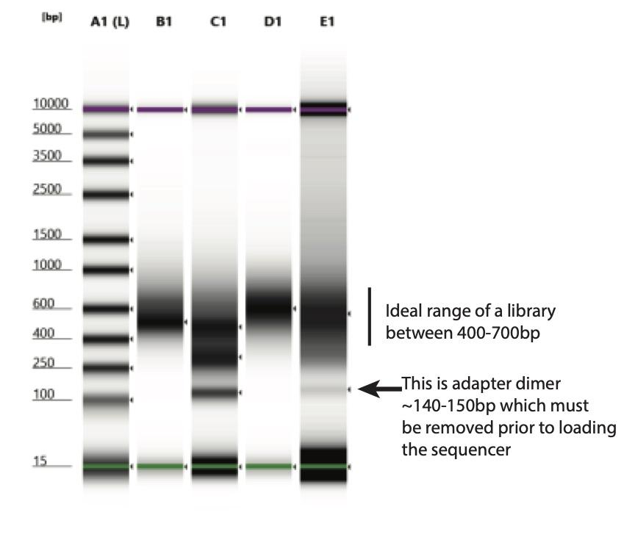
  - Adaptor dimers show up ~146bp. If adaptor dimers are present, clean up the library using a 0.8x SPRI clean-up. If >10% of the sample is adaptor dimer, it will typically take 2 or even 3 clean-ups before all the adaptor dimers are removed. Alternatively, perform a gel extraction, cutting at approximately 450-800bp in length. After any clean-ups, re-qubit and re-assess library size. This step is critical as adaptor dimers will cluster better on the illumina platform, so even if you only have 5% adaptor dimers in a sample, up to 20% of the final reads will originate from the adaptor dimers.
  - If you are unable to use a high sensitivity capillary electrophoresis system, you can perform a diagnostic PCR instead as a proxy for the overall library. Take 1 uL of the final pool and perform a standard PCR reaction for 30 cycles using the Illumina universal primers:
P7: CAAGCAGAAGACGGCATACGAGAT
P5: AATGATACGGCGACCACCGAGATCTACAC

 | 1x | __x
2x PCR master mix | 25 uL
10µM P5 primer | 1 uL
10µM P7 primer | 1 uL
Library sample | 1 uL
Water | 22 uL
Total volume | 50

Cycling conditions for diagnostic PCR:
98C 1 min
98C* 10s
60C* 15s x 30 cycles
72C* 75s
72C 5 min
4C hold

*Thermocycling conditions will vary depending on the polymerase used. Be sure to refer to the PCR kit recommendations and calculate Tm for the P5, P7 primers.

Run 10uL of the PCR reaction and 10uL of a 1:5 dilution of the PCR reaction to assess the presence or absence of the adaptor dimer. If adaptor dimers are present, clean up the original library (not the diagnostic PCR) using a 0.8x SPRI clean-up. If >10% of the sample is adaptor dimer, it will typically take 2 or even 3 clean-ups before all the adaptor dimers are removed. The image below shows a library that is smaller than ideal (avg size ~ 300bp whereas the ideal avg size should be around 500bp so future fragmentation incubations should be reduced) and as well, there appears to be adaptor dimer which shows up around 150bp. This library should be cleaned up by SPRI bead to remove additional adaptor dimer.
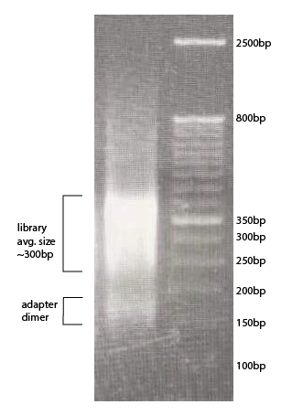
  - Size distribution measurement on ImageJ: (Optional)
    - Open the gel image on ImageJ
    - Select a rectangular region corresponding to the lane along which you want to plot the size profile
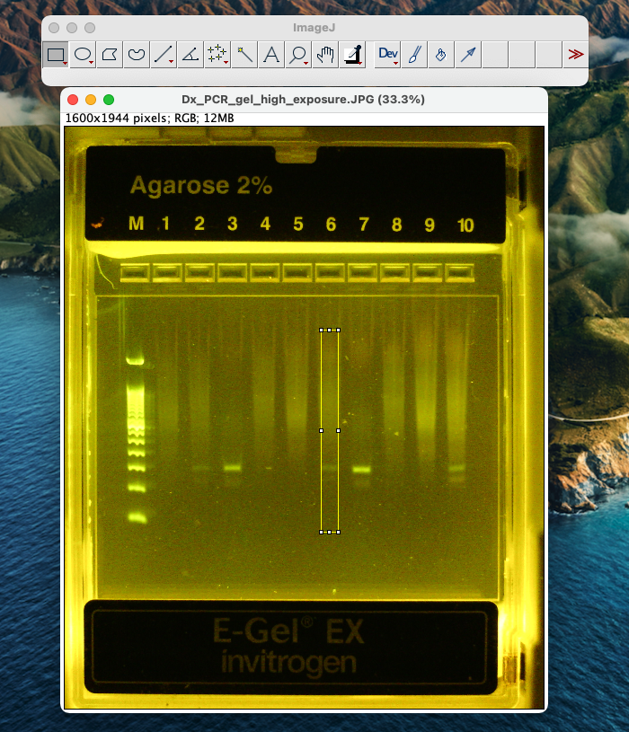
    - Open the gel image on ImageJ
    - Go to Edit>Options>Plots and check the “Vertical” box. This ensures that the distribution is drawn along the vertical axis, while averaging intensity along the horizontal width of the box.
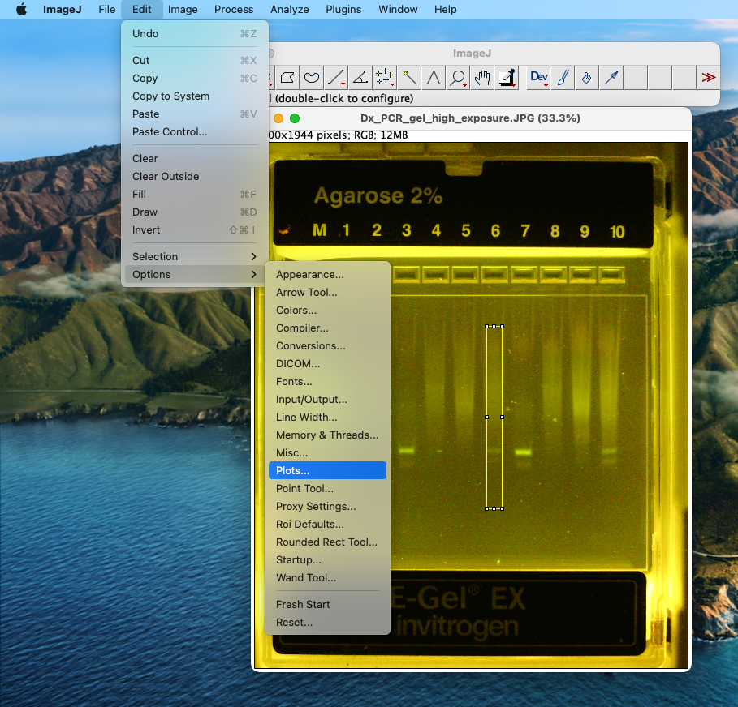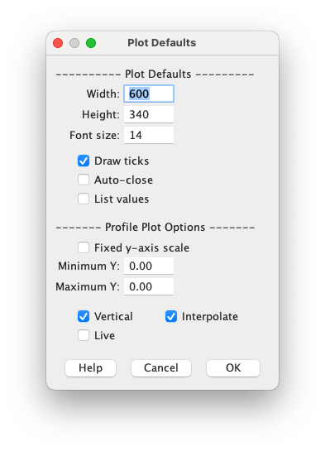
    - Now click on Analyze>Plot Profile. This should generate an intensity distribution along the rectangular region.
    - For more information and additional functionality, see ImageJ’s documentation here.
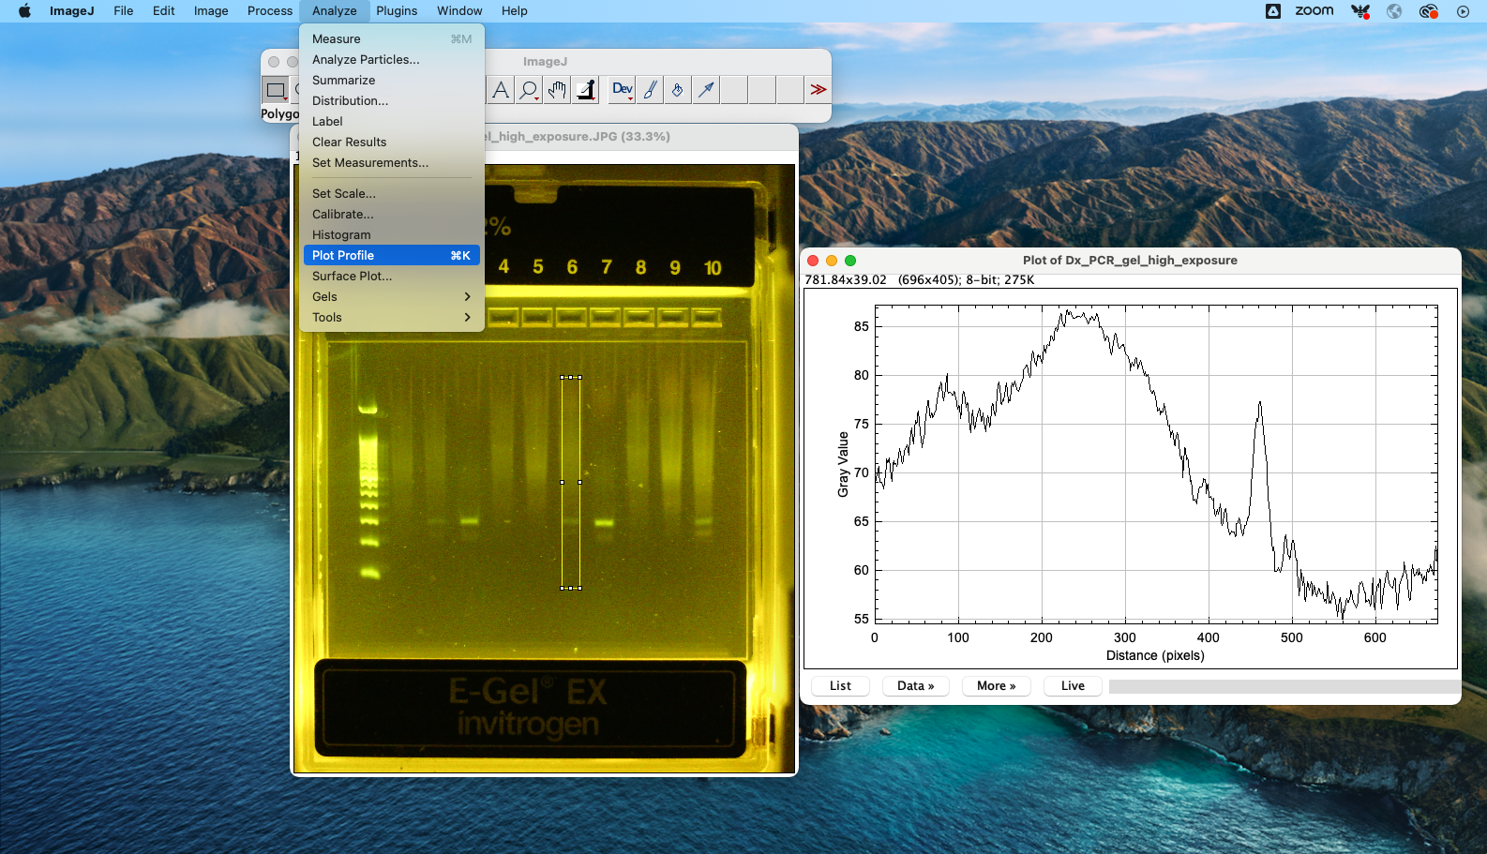
    - Note: Instead of selecting a rectangular region, you can also draw a line and plot intensity along the line, but this will be noisier.
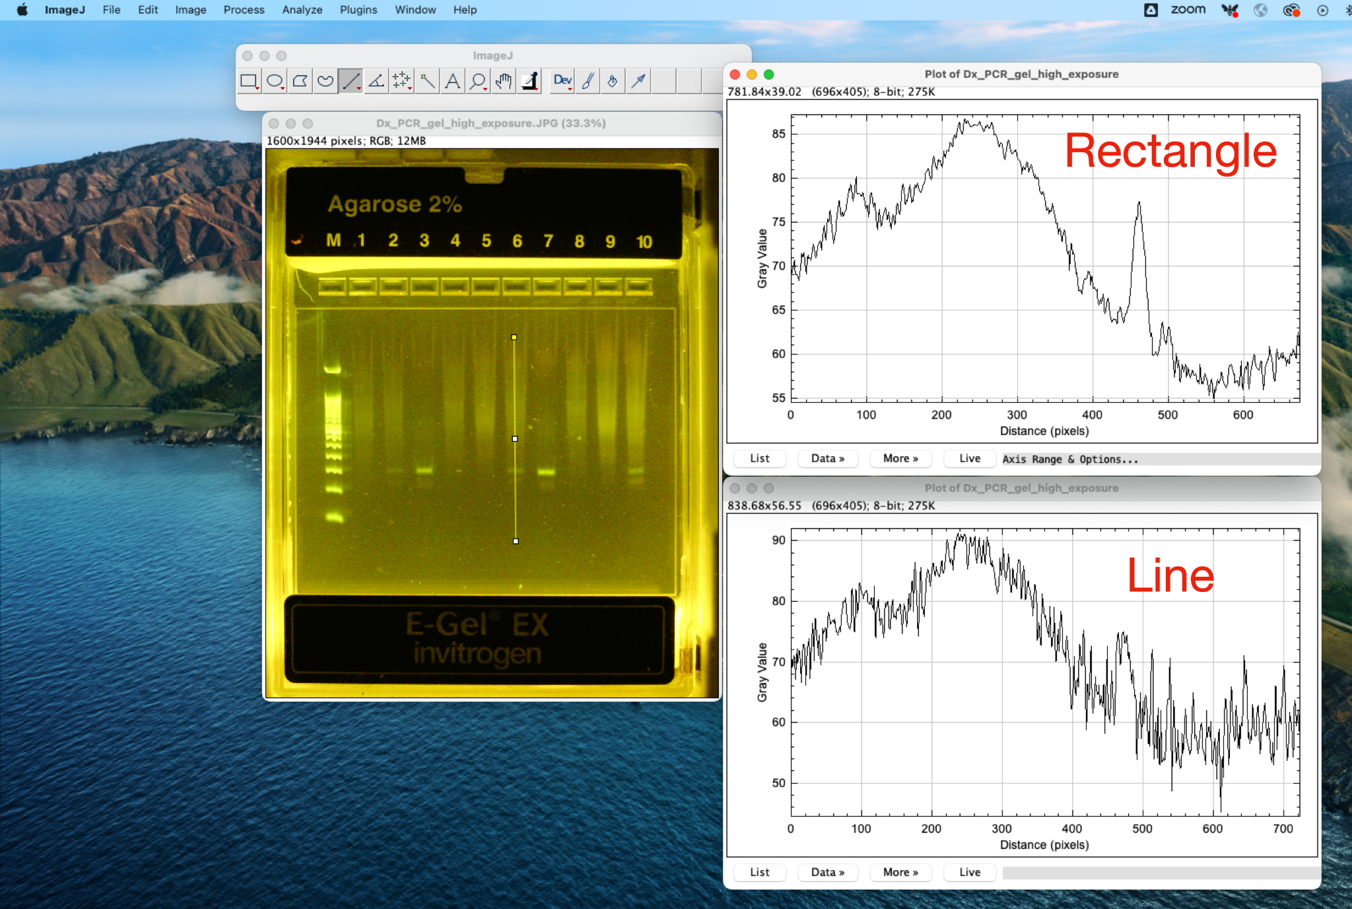
    - Repeat the process for the ladder and all the samples of interest.
    - You can save a screenshot of the distributions and annotate them based on the ladder.
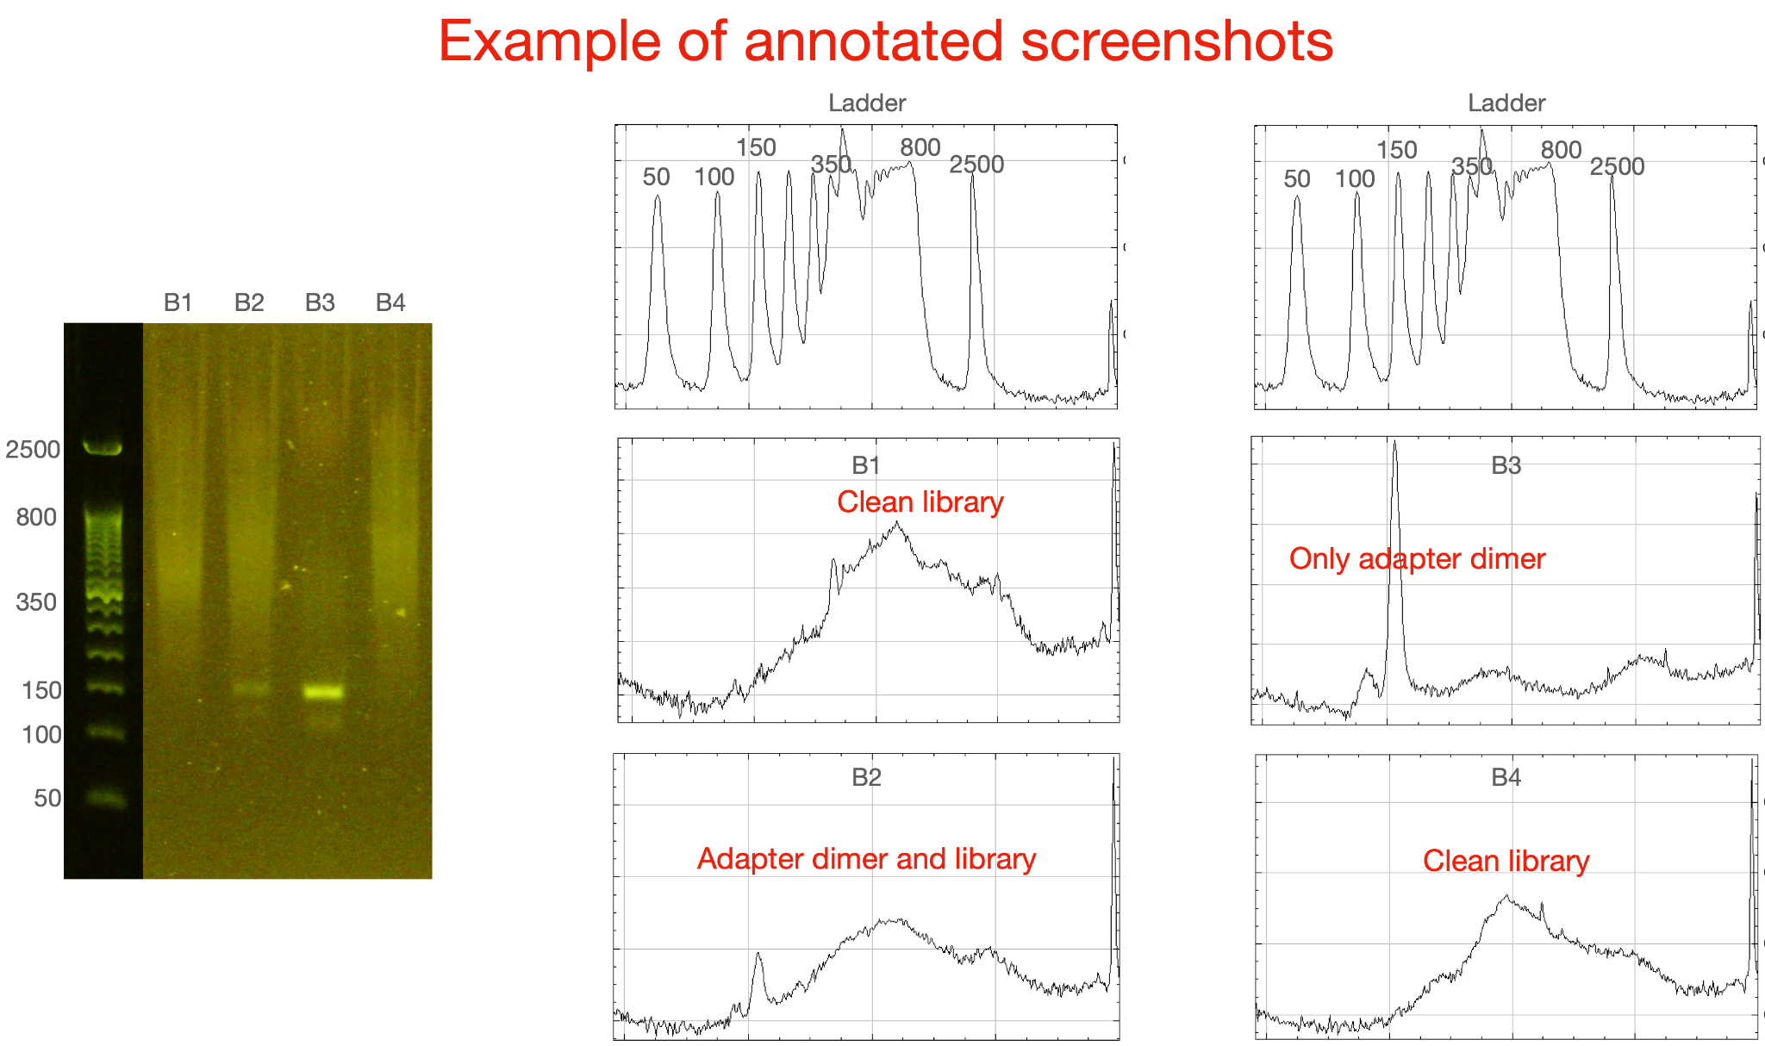

- Pool the samples and water controls. Samples should be pooled to equivalent amounts and water controls to 1/5th the amount of a real sample. For example, pool 10ng from all the samples and 2ng of the water controls. This is your final pool. Please use this google sheet as a template for pooling: https://docs.google.com/spreadsheets/d/1MsfYvv0HlJm4bUOxpgi3AO0AL1jubK5Tx0AgkitF9To/edit?usp=sharing
  - example:
Sample | Qubit ng/uL | Desired amount in pool | Volume to pool
CSF1 | 5 ng/uL | 5 ng | 1 uL
CSF2 | 10 ng/uL | 5 ng | 0.5 uL
CSF3 | 2 ng/uL | 5 ng | 2.5 uL
Water control | 1 ng/uL | 1 ng | 1 uL

- Qubit and assess the final pool library size by tapestation/bioanalyzer/etc.
  - Convert the qubit quantification into nM concentration using this formula and the average size of the library. 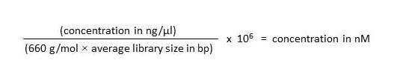
  - Compare the qubit result to the capillary electrophoresis systems you used. The results should be within 2x of each other.
- Perform an Illumina library quantification by qPCR. We use the Kapa Library Quantification Kit (Cat. no. KK4828) for the Illumina platform. Compare the qPCR results to the qubit and capillary systems. The result should be within 2x of each other.

6. iSeq Loading

Goal: Load final pool onto Illumina iSeq platform, and use basespace for run monitoring/demultiplexing.

Workflow: How to Start Using the iSeq 100 System, Sequencing Run Setup, Navigating Basespace, Record keeping

Considerations:
- iSeq is a user installed system. Please keep packaging, it will be useful if the iSeq needs to be returned to the manufacturer.
- Optional Equipment (highly suggested):
  - Uninterruptible Power Supply (UPS) for regulating power surges and as a back-up power source.
  - Mouse and Keyboard.
- Basespace accounts are free with limited storage (sufficient for many iSeq runs). It is used for run monitoring and demultiplexing.
- iSeq will save two copies locally, one on the iSeq system and another copy preferably on a server. IT will have to set up the connection.
- Stable internet is recommended. If the internet cuts out during the run, universal copy service will continue to ping basespace and resume data upload when connection resumes.
- Store and thaw cartridges with arrow pointed up.
- Thaw cartridges in 4C a day before running the sequencer or 4+ hours in a water bath the day of.

Protocol:
- Sample Preparation/Dilution
  - Sample QC
    - Tapestation/Bioanalyzer/Fragment Analyzers are preferred methods to quantify and measure fragment size.
    - qPCR and Qubit are Illumina approved methods to quantify library concentration.
    - If using Qubit, convert ng/µL as follows:
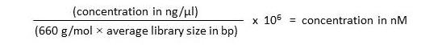
  - Dilute pool to loading concentration in 100µL using the formula: C₁V₁ =C₂V₂
    - Recommend starting at 100pM and scale in 10pM increments as needed.
    - Example: Pool concentration is 4.4nM, 100pM Loading concentration
(4400pM)(V₁) = (100pM)(100µL) ; V₁ = 2.27µL of pool in 97.72µL of TE/EB/Water
  - PhiX is used as an Internal Control. Dilute 10nM stock to loading concentration (100pM) and aliquot 20-50µL into tubes. Aliquotes can be stored at -20C and used as needed.
    - Spike in 1-2µL into previously diluted pool (1-2% PhiX in final)
- Run Set Up
  - Benchtop Work
    - Remove cartridge from 4C and rotate a couple of times. If you hear ice, leave at room temperature for another hour. Also remove flow cell from 4C at this time.
      - After rotating the cartridge, gently tap the cartridge on the benchtop a couple of times.
    - Remove flow cell from the packaging and insert it into the slot in the cartridge. Push into the cartridge until it “clicks.”
    - Fully puncture the foil seal on the cartridge with a 200µL pipette tip.
    - Transfer 20µL of 100pM (or optimized loading concentration) pool into well.
      - Find the bottom of the well with the tip, slightly raise the pipette tip and dispense the full 20µL volume.
    - DO NOT ROTATE/FLIP KIT AFTER ADDING SAMPLE.
  - At the sequencer (Refer to iSeq step-by-step guide below)
    - Press “Sequence” on the touchscreen and the door will open
    - Push the cartridge (with flowcell) into the iSeq. There is only one correct orientation (flow cell pointing into machine)
    - Close door using the touch screen
    - Select “Run Monitoring and Storage” and sign in on Basespace
    - Run name should be unique (ie. “YYYYMMDD_FirstName_Run#”)
    - Read Cycle should be Read1: 146, Index1: 12, Index2:12, Read2: 146
    - Select Advance to expand Options and select Browse to select your samplesheet.
    - Press Start Run
    - Sequencer will go through 15 minutes of pre-run check and start automatically.
- Troubleshooting (Refer to iSeq step by step guide below)
  - Slack/Email Biohub Team.
  - Contact Illumina Tech Support via Email or phone. Especially in cases where you suspect there is a fluidics issue. They will send replacement reagents if necessary.

Resources:
Genomics Platform: Sequencing Overview
Genomics Platform: Loading iSeq Step by Step with BaseSpace Troubleshooting (including biohub iSeq set up)
iSeq System Sequencing Guide

Appendix

Appendix A: Catalog links and numbers
See linked Google Sheet for catalog numbers and note

Appendix B: Enrichment Methods

For target enrichment, we recommend first considering Illumina’s VSP or RPIP panels, which cover many commonly used human pathogen/AMR targets and are well validated. There are other commercial enrichment kits that also work well. (e.g. Twist Bioscience) If your targets of interest are not included in these panels, here are some options:
- Custom panel designs offered commercially (e.g. Illumina or Twist custom panel)
- MSSPE (requires custom primer design)
- FLASH (requires custom probe design)

Appendix C: DASH Protocol

This is a method for depletion of host amplicons after library preparation.
https://www.protocols.io/view/dash-protocol-6rjhd4n

Appendix D: Dual guide RNA transcription for DASH and FLASH

https://www.protocols.io/view/in-vitro-transcription-for-dgrna-3bpgimn

Appendix E: SPRI bead QC protocol

January 2025: The Rapid Response Team at Chan Zuckerberg Biohub SF does NOT recommend making homemade SPRI beads due to batch inconsistencies. The previous version of this protocol was retired in January 2025. The SPRI bead QC protocol is retained in this document, as it may be used to check any SPRI / AMPureXP / etc beads as necessary.

Overview

SPRI (Solid phase reverse immobilization) beads are highly useful for purifying and size selecting nucleic acid (gDNA, PCR amplicons, NGS libraries, gRNAs).

As demonstrated in the image below, DNA binds to SPRI beads, which can be washed before elution to collect the DNA. The ratio of SPRI bead volume to sample volume may be adjusted to control selection for DNA by base pair size.
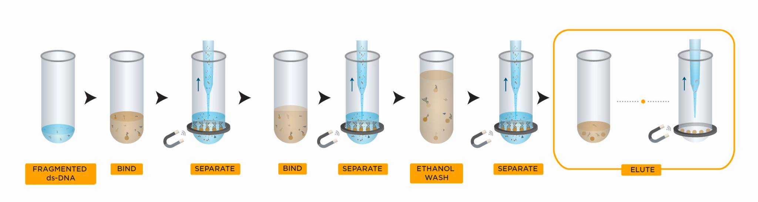
Image from https://www.beckman.com/reagents/genomic/cleanup-and-size-selection/size-selection.

Reagents and Materials

Reagent | Vendor | Catalog No.
50bp ladder | Invitrogen | 10416-14
Certified Molecular Biology Agarose | BIO-RAD | 1613102
6x TriTrack DNA Loading Dye | Thermo Scientific | R1161
1X TAE | Various
Nuclease-free water | Ambion | AM9937

Protocol

Workflow: SPRI bead Quality Control
- Perform a SPRI clean
- Evaluate DNA elution (Qubit)
- Evaluate DNA size selection (Gel, Tapestation)

SPRI Bead Quality Control

We test our SPRI beads by performing several size selections at different bead:sample ratios on a 50bp DNA ladder at a 1:50 dilution. Final concentration of sample input is 500ng/50uL (10ng/uL).

[Perform a SPRI Clean]
- Mix the SPRI beads well by vortexing before continuing.
- In an RNase-free hood, aliquot 700uL of the SPRI beads for QC.
- If necessary, equilibrate SPRI beads to RT for 30min prior to continuing to next steps.
- The following steps can be performed on a bench; a hood is not necessary.
- Create a 1:50 dilution of 50bp DNA ladder in a labeled 1.5mL tube.
12uL of 50bp DNA ladder
588uL nuclease-free water
- Keep an aliquot of the 1:50 dilution of 50bp DNA ladder for HS dsDNA Qubit quantification and for a Tapestation/gel run.
- Prepare 6mL of 80% EtOH
4.8mL 100% EtOH
1.2mL nuclease-free water
- Prepare labeled PCR strip tubes with the following SPRI bead and 1:50dil 50bp ladder volumes:

Tube | 1 | 2 | 3 | 4 | 5 | 6 | 7 | 8 | 9 | 10 | 11
bead:sample | 0.35 : 1 | 0.5 : 1 | 0.7 : 1 | 0.75: 1 | 0.8 : 1 | 0.85: 1 | 0.9 : 1 | 1.1 : 1 | 1.4 : 1 | 1.7 : 1 | 2 : 1
50bp ladder 1:50 (μL) | 50 | 50 | 50 | 50 | 50 | 50 | 50 | 50 | 50 | 50 | 50
SPRI beads (μL) | 17.5 | 25 | 35 | 37.5 | 40 | 42.5 | 45 | 55 | 70 | 85 | 100

- Mix SPRI beads + ladder thoroughly by pipetting up and down >10x.
- Pulse spin the tubes, but be sure not to spin down beads. Incubate for 5 mins at room temperature.
- Place samples on magnetic rack, and incubate for 5 mins on the rack.
- Remove supernatant.
- Add 200uL of 80% EtOH to samples while on the magnetic rack. Do not disturb beads. Incubate at room temperature for 30s then remove the supernatant.
- Repeat EtOH wash step for a total of 2 washes.
- Air dry the beads for up to 5 mins while on the magnetic rack. Watch beads carefully throughout this incubation to avoid overdrying; smaller bead pellets dry faster.
- Remove tube from magnetic rack. Elute DNA from beads 27uL nuclease free water.
- Vortex or pipette to mix well. Spin tubes and incubate for a minimum of 2 mins at room temperature off the magnetic rack.
- Place on magnetic rack until solution is clear ~ 5 mins.
- Remove 25uL of the supernatant and transfer to a clean nuclease free PCR tubes

[Check DNA Elution Using dsDNA Qubit]
- Quantify the initial 1:50 diluted 50bp ladder input and all of the SPRI elutions by HS dsDNA Qubit to assess yield.
  - Follow instructions provided by the manufacturer. Each HS dsDNA Qubit assay requires 1uL per sample.
  - You can perform the SPRI yield calculations by hand or using the calculation sheet below. An example of typical results:

bead:sample | 0.35 : 1 | 0.5 : 1 | 0.7 : 1 | 0.75: 1 | 0.8:1 | 0.85:1 | 0.9 : 1 | 1.1 : 1 | 1.4 : 1 | 1.7 : 1 | 2 : 1 | L
% Yield | ~2% | 5 - 8% | 30 - 45% | 30 - 45% | 30 - 45% | 30 - 45% | 45 - 60% | 55 - 70% | 65 - 80% | 65 - 80% | 65 - 87% | Input

bead:sample | 0.35 : 1 | 0.5 : 1 | 0.7 : 1 | 0.75: 1 | 0.8:1 | 0.85:1 | 0.9 : 1 | 1.1 : 1 | 1.4 : 1 | 1.7 : 1 | 2 : 1 | L
1:50 50bp volume (uL) | 50 | 50 | 50 | 50 | 50 | 50 | 50 | 50 | 50 | 50 | 50 | 50
SPRI volume (uL) | 17.5 | 25 | 35 | 37.5 | 40 | 42.5 | 45 | 55 | 70 | 85 | 100 | -
Elution volume (uL) |  |  |  |  |  |  |  |  |  |  |  | -
(ng/uL) from Qubit
Final Mass | Elution vol * Elution concentration
% Yield | Final Mass / Input Mass * 100

[Check DNA Elution Using a Gel]
(Alternatively, run on a Bioanalyzer or Tapestation, though it is more cost effective to run a gel).
The image below can be used as a reference for the rest of the protocol.

- Make a 1.8% agarose gel in a clean Erlynmeyer flask or bottle
0.9g agarose (listed in reagents)
50mL of 1x TAE
- Heat the solution in the microwave for 30 seconds. If using a bottle, you can put a lid on but do NOT tightly seal the lid, to allow hot air to escape.
- Watch the solution through the door of the microwave and stop the heating if you see any bubbles due to boiling. Swirl the flask/bottle if necessary.
- Heat the solution until the agarose is fully dissolved; pause heating if the solution boils.
- Mix solution well by swirling and cool for ~5 minutes.
- Add 5uL 10,000x SYBR Gold DNA stain.
- Mix the gel solution well - it should be homogeneous liquid - before casting.
  - Note: If the gel solution begins to solidify, briefly heat the solution in the microwave, avoiding boiling.
- Identify an appropriate gel mold, casting tray, and comb with at least 13 wells.
- Pour the 1.8% agarose into the tray, avoiding bubbles at the top of your gel. Pour enough gel solution to cover the comb teeth, but do not overfill.
- While the gel is cooling, prepare a labeled PCR strip with 9uL of each of the eluted samples from the SPRI clean.
- Add an additional labeled well with 9uL of the initial 1:50dil 50bp ladder input. This is the positive control.
- Briefly pulse spin the sample tubes.
- Add 2uL of 6x DNA loading dye (listed in reagents) to each of your 9uL eluted samples and your positive control sample.
- Mix the samples and loading dye well and briefly pulse spin.
- Prepare a gel box large enough to hold your gel with the running buffer (1x TAE buffer).
- Check if the gel is solidified.
- Remove the comb and, keeping the gel in the tray, remove from the mold.
- Place the gel with tray in the gel box with the wells on the negative (black) side and the other end of the gel is on the positive (red) end.
- Load 7uL of the sample + dye into each gel well and record which sample is in which well.
  - Note: You can load 7-10uL into the gel, depending on the size of your gel.
- Place the lid on the gel box, matching electrodes by charge/color.
- Turn on the voltage box.
- Connect the electrodes to the voltage box, matching the electrodes to correct color.
- Set the voltage to 120V and run the gel at 120V for 40 mins by pressing the image of the running person. Confirm that the voltage is running by observing bubbles in the running buffer.
  - Note: Gel time is approximate – run is complete when loading dye is ~2/3 of the way down the gel.
  - Note: Make sure to return soon after the gel is done running; samples will dissipate if the gel is left after run is complete.
- Turn off the voltage box and remove the lid.
- Look at the gel and check if the loading dye is ~⅔ of the way down the gel. You should visibly see the blue color of the loading dye in the gel.
  - Note: If your gel runs over (no loading dye observed), repeat the gel run with remaining samples and run at the same voltage for less time.
- Image the gel on a gel imager using the nucleic acids, SYBR Gold and auto exposure settings.
- Analyze your gel for binding cut-off at each ratio of beads:sample by comparing your gel image to previous gel images (examples provided below).
- (optional) Create a chart of the base-pair collection cut off based on SPRI to sample volume ratio.
- Bead batches or ingredients may result in shifts in binding cutoffs. Adjust experimental protocols accordingly.

Typical results:
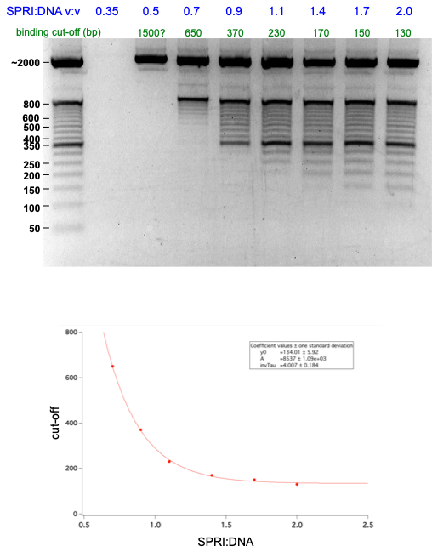

DNA Retention QC Excel Sheet:
https://docs.google.com/spreadsheets/d/11Xfh6mTIV3Bewbo8Z1jLnkEf_z1U1S5pwLoi-ULV25M/edit?usp=sharing

SPRI Beads Powerpoint: https://docs.google.com/presentation/d/1O_kWfL-MQBRO0w84lxQxdBf-ooSpEUmUOyN-OqCecWk/edit#slide=id.g9ee72de1f0_0_30

Appendix F. Post-PCR Decision Tree

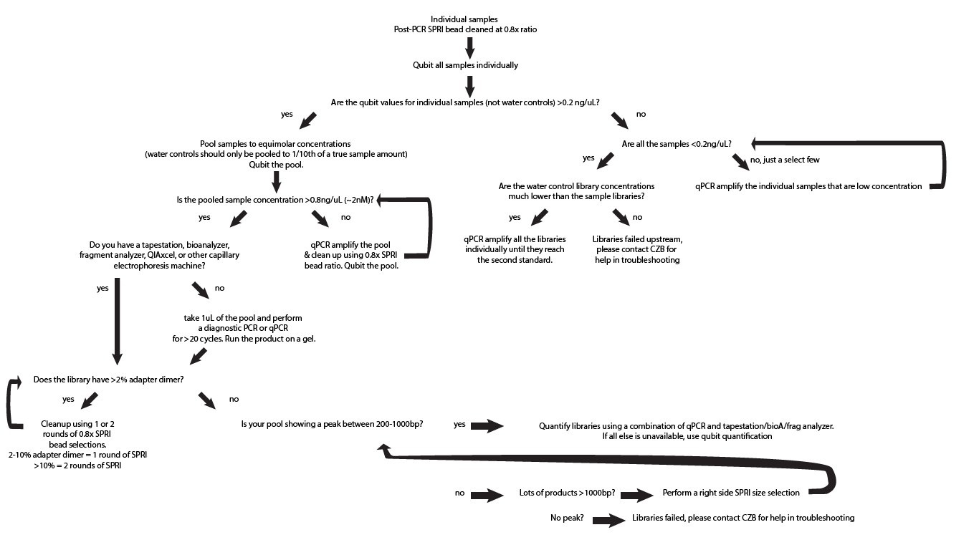

Appendix G: ERCC Dilutions SOP

Caution: ERCC Dilutions should be carried out in the Pre-PCR (RNAse free) workstation to avoid any contaminants. In addition, the dilutions should be carried out on ice to maintain the ERCC integrity.

Materials and Reagents

Reagent | Vendor | Catalog No.
ERCC RNA Spike-In Mix | Invitrogen | 4456740
Qubit RNA HS Assay Kit | Invitrogen | Q32855 or Q32852

The Stock ERCC tube comes with 10µL of product. 1µL is used for the RNA Qubit, whilst the rest of the 9µL can be used for the ERCC dilutions.

Dilution Steps:
- RNA Qubit the ERCC, prepare Qubit RNA HS working solution through diluting the Qubit RNA HS Reagent 1:200 in Qubit RNA HS Buffer. Prepare your two standards by adding 190µL of Qubit RNA HS working solution to 10µL of each respective standard. Lastly, use 1µL of undiluted ERCC to 199µL of Qubit RNA HS working solution.
- Dilute the ERCC to achieve 50pg/µL, aliquoting the ERCCs into pcr strip tubes in 15µL volume (or your desired volume)
- Calculate the dilution factors according to the table attached below and excel sheet provided as an example:

Concentration (ng/µL) | 25.4 | Calculation
Total Mass (ng) | 228.6 | Concentration (25.4ng/µL) * Total ERCC Volume (9µL)
Total Mass (pg) | 228600 | Total Mass (228.6 ng) * 1000
Dilution to 50 pg/µL (Total Volume) | 4572µL | =Total Mass (228600pg)/ desired concentration (50 pg/µL)
Volume of Water | 4563 | Total Volume – ERCC Volume (e.g. 4572µL – 9µL)

- After the dilution is carried out, aliquot 15µL into PCR Strips and Freeze at -80ºC. Each aliquot should only be used once.

Formulas used:

Concentration = mass/volume

Appendix H: Secondary library amplification SOP (KAPA or Q5)

To perform additional library amplification, our previous recommendation was to use the KAPA HiFi real-time HotStart Library Amp Kit (KK2702). However, this kit was discontinued in early 2024. Given this, our alternative recommendation is to use the KAPA HotStart Library Amp Kit (KK2611/KK2612). In case you are not able to acquire this alternative KAPA kit, you may also consider using the Q5 master mix that is used for barcoding PCR. Note that all three approaches involve using the universal P5/P7 primers. Protocols for each of the above methods can be found below:

Appendix Ha. Library amplification using KAPA HiFi HotStart Library Amp Kit (KK2611/KK2612)
Appendix Hb. Library amplification using Q5 (NEB M0492S/M0492L)
Appendix Hc. Library amplification using KAPA HiFi real-time HotStart Library Amp Kit (KK2702)

Appendix Ha. Library amplification using KAPA HiFi HotStart Library Amp Kit (KK2611/KK2612)

This protocol is based on the KAPA HiFi HotStart Library Amp Kit (KK2611), which performs identically to the KK2702 kit, except that it does not include fluorescent dyes and standards.

Given this, the amplification can be performed on a regular PCR machine, rather than relying on a qPCR machine. However, without the fluorescent standards, the number of amplification cycles needs to be pre-determined.

- Perform this PCR amplification step if after cleaning out the digested fragments and adapter dimers your library concentration is too low for loading onto a sequencer.

- Quantify the concentration of the initial library using Qubit.

- Thaw the reagents and P5/P7 universal Illumina primers
P7: CAAGCAGAAGACGGCATACGAGAT
P5: AATGATACGGCGACCACCGAGATCTACAC

- For each library to be amplified, setup the amplification reaction as follows:

Component | Volume (µL)
KAPA Master Mix (2x) | 25
P5/P7 primer mix (5µM) | 2
DNA (bring up to volume with H₂O if necessary) | 23
Total Volume | 50

- Determine the number of cycles of PCR needed based on the table below. This table is from the KAPA amplification kit manual. Note: from our experience, fewer cycles may be needed than is indicated. For low inputs (<10 ng), amplifying for two cycles fewer than the lower range of what is recommended in the table seems sufficient*.
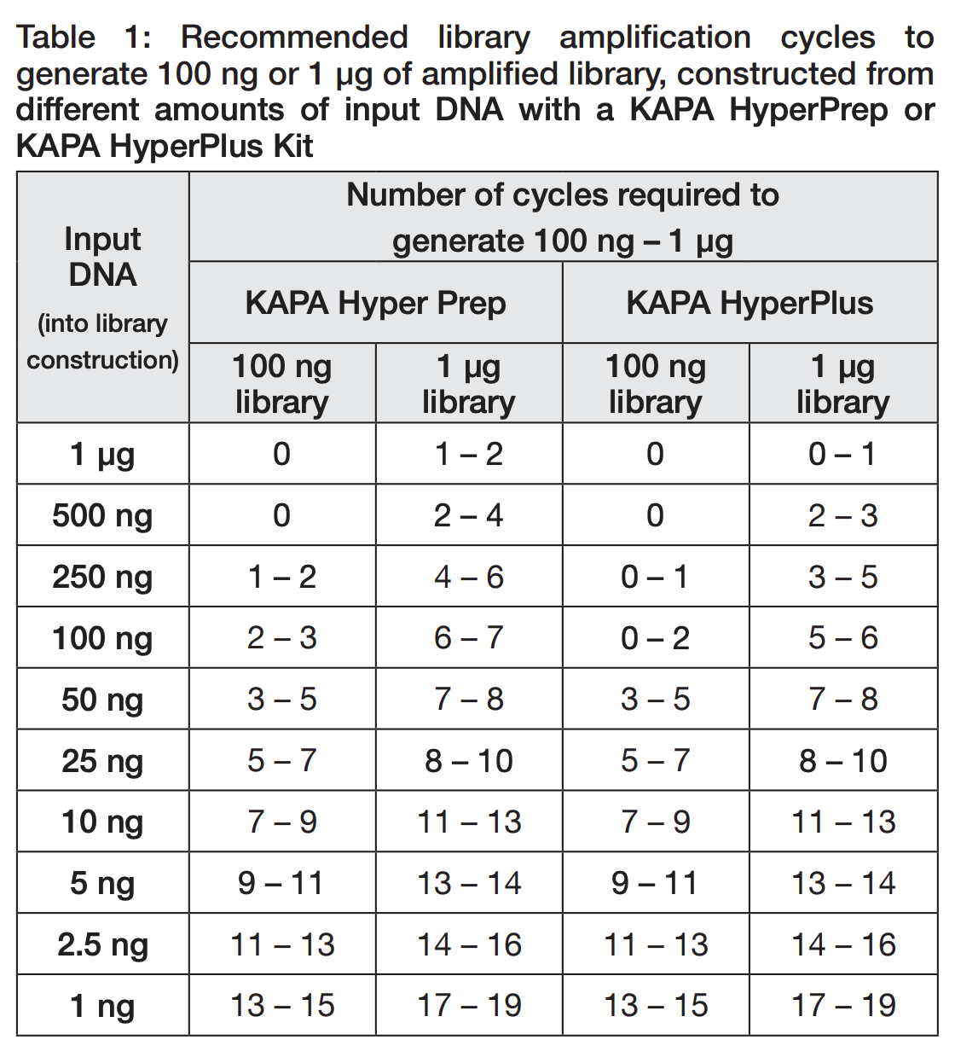
*For example, if the Qubit value for a library is 0.2 ng/µL, the total input amount is 0.2*23 = 4.6 ng. This is closest to 5 ng, and the lower range for this input amount is 9-11 cycles. Subtracting two, 7 cycles of amplification are likely sufficient.

- Use the following cycling conditions for PCR:

Temperature | Time | Cycles
98°C | 45 sec | 1
98°C | 15 sec | X*
63°C | 30 sec | X*
72°C | 1m 45 sec | X*
72°C | 20 sec | X*

*X is determined based on input, as indicated above.

- After amplification, perform a 0.8x or 0.9x SPRI clean-up and then quantify and visualize the size distribution to assess quality and quantity of the library.

Appendix Hb. Secondary library amplification using Q5 polymerase

Reagents: NEBNext® Ultra™ II Q5® Master Mix (M0544S/M0544L, NEB). Note: this master mix is also used in the library preparation protocol.

This protocol is for amplifying libraries that have already been through the barcoding PCR step. This second amplification is when insufficient amounts of libraries are made, and is an alternative to KAPA amplification. (If you have KAPA reagents, use KAPA instead.)

This protocol does not include fluorescent dyes and standards.Given this, the amplification can be performed on a regular PCR machine, rather than relying on a qPCR machine. However, without the fluorescent standards, the number of amplification cycles needs to be pre-determined.

- Quantify the concentration of the initial library using Qubit.

- For each library to be amplified, setup the amplification reaction as follows:

Component | Volume (µL)
Q5 Master Mix (2x) | 25
P5/P7 primer mix (5µM each) | 2
DNA (bring up to volume with H₂O if necessary) | 23
Total Volume | 50

- Determine the number of cycles of PCR needed based on the table below. This table is from the KAPA amplification kit manual, but seems to also work for Q5. However, fewer cycles may be needed than is indicated. For low inputs (<10 ng), amplifying for two cycles fewer than the lower range of what is recommended in the table seems sufficient*.
*For example, if the Qubit value for a library is 0.2 ng/µL, the total input amount is 0.2*23 = 4.6 ng. This is closest to 5 ng, and the lower range for this is 9-11 cycles. Subtracting two, 7 cycles of amplification are likely sufficient.

- Cycling conditions for PCR:

Temperature | Time | Cycles
98°C | 1 min | 1
98°C | 10 sec | X*
65°C | 75 sec | X*
65°C | 5 min | 1
4°C | hold | 1

*X is determined based on input, as indicated above.

- After amplification, perform a 0.8x or 0.9x SPRI clean-up and then quantify and visualize the size distribution to assess quality and quantity of library.

Appendix Hc. Library amplification using KAPA HiFi real-time HotStart Library Amp Kit (KK2702)

This protocol is based on the KAPA HiFi HotStart Real-Time Library Amp Kit (KK2702, discontinued as of Jan 2024)

- Perform this Real-Time PCR amplification step if after cleaning out the digested fragments and adapter dimers your library concentration is too low for loading onto a sequencer. We find that this is almost always required.

- Thaw Kapa HiFi Real-Time Amplification Master Mix and Standard 2 on ice

- Prepare the following reaction for each sample:

Reagent | Volume (1X)
2X Kapa HiFi Real-Time Amplification Master Mix | 25 µL
5 µM Universal Illumina primers:  P7: CAAGCAGAAGACGGCATACGAGAT  P5: AATGATACGGCGACCACCGAGATCTACAC | 2 µL
DNA (bring up to volume with H₂O if necessary) | 23 µL
 | 50 µL

- Place each sample in a tube or strip of tubes that is physically separated from the others, so that they can be removed one at a time.
- Put 50 µL of Standard 2 in a separate PCR tube

Use the following cycling conditions:

Temperature | Time | Cycles
98°C | 45 sec | 1
98°C | 15 sec | 25
63°C | 30 sec | 25
72°C | 1m 45 sec | 25
Plate read |  | 25
72°C | 20 sec | 25

- Watch the qPCR graph during the plate read. When a sample reaches the fluorescence threshold given by standard 2, remove that sample DURING the 72°C for 20 second timeframe after the plate read.

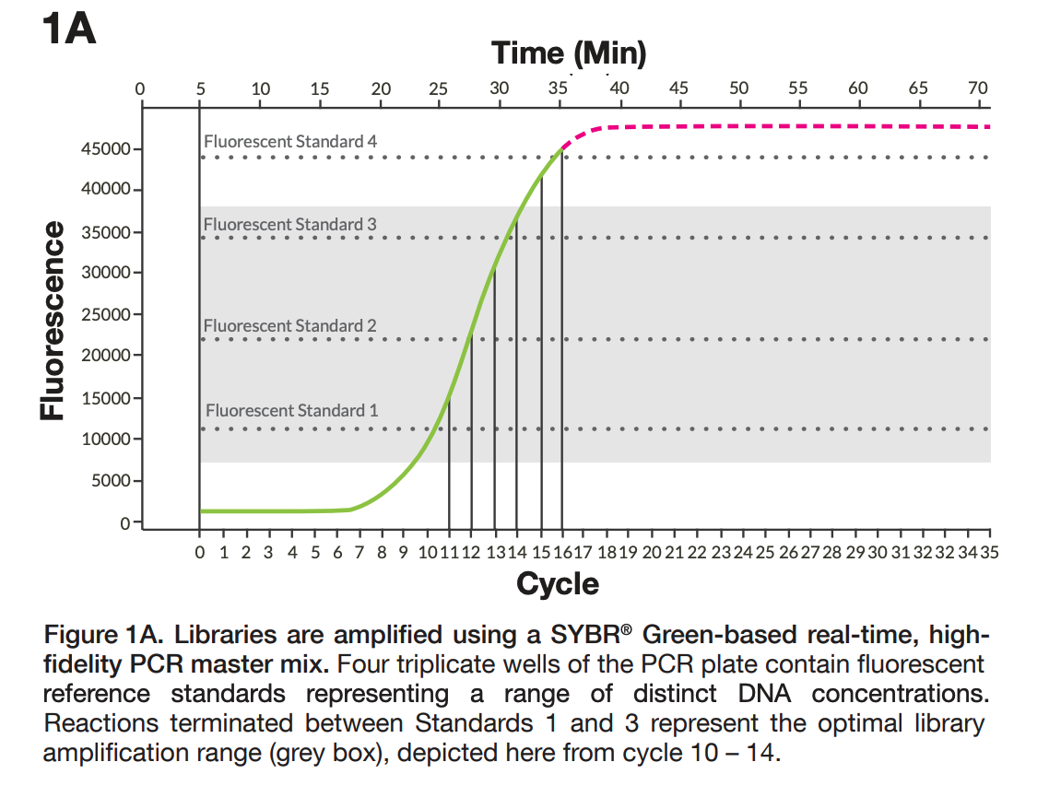

Perform a SPRI cleanup at a sample:bead ratio of 0.8x or 0.9x to remove amplification reagents, and elute in a suitable volume of water.

Appendix I: Right side SPRI size selection

Right side size selection
- Thoroughly shake to resuspend the SPRI beads. Add the required volume of SPRIselect for the desired ratio to the sample.
  - 0.5x for <1000bp
  - 0.6x for <800bp
  - 0.7x for <600bp
- Mix the total reaction volume by pipetting 10 times and incubate at RT for 5 minutes
- Place the tube on the magnetic stand and allow the beads to fully separate, ~2-3 minutes.
- Transfer the clear supernatant, which contains the Right Side Size Selected sample, to a new tube. The tube with the remaining beads can be discarded.
NOTE: Care should be taken not to aspirate more than a trace amount of beads during this step as the undesired larger fragment sizes are associated with the beads. Significant bead transfer will cause tailing into the larger size range.
- Add the required volume of SPRI beads, using the calculation below, to the supernatant from Step 4 above. This will bind the fragments in the supernatant to the new SPRI beads.
TIP: Sample Volume μL * (1.8x – the initial ratio) = volume of SPRI beads
Example: 50 μL * (1.8 – 0.7) = 55 μL of SPRI
- Mix the total reaction volume by pipetting 10 times and incubate at RT for 5 minutes
- Place the tube on the magnetic stand and allow the beads to fully separate, ~2-3 minutes.
- Remove and discard the clear supernatant.
- With the tube still on the magnet, add 180 μL of 80% ethanol and incubate at RT for 30 seconds. Remove and discard the ethanol supernatant.
- To elute the sample add ≥ 20 μL of water. Mix the total elution volume by pipetting 10 times to resuspend the beads and incubate at RT for 5 minutes
- Place the tube on an appropriate magnetic stand or plate and allow the SPRI beads to settle to the magnet. Settle times will vary; a higher elution volume or weaker magnets will require a longer settle time.
- Transfer the eluate (size selected sample) to an appropriate storage vessel.

Appendix J: Metagenomics protocol for nanopore ONT platforms

Biohub Protocols: Nanopore Metagenomics (mNGS)

Appendix K: TruSeq-compatible mini adapters

For complete information, please see the Mini adapter info sheet
Background and introduction
Adapter dimer is an unwanted byproduct of library preparation, especially when working with low input samples. Size-specific SPRI bead cleanups are used to remove the dimers which are typically smaller than the target library size (<200bp). However, dimer can persist which interferes with sequencing output and quality.

To address this issue of adapter dimer, we share new TruSeq-compatible mini adapters. These adapters can swap into the current Biohub mNGS library preparation protocol (and others) with minor modifications and are compatible with TruSeq-based indexing primers.

The adapters are shorter than the typical NEB/Illumina adapters so they can be used at higher concentrations and still be removed efficiently with a single SPRI bead clean after barcoding PCR. Mini adapter dimer is ~50bp whereas traditional adapter dimer is ~150bp.

Based on our pilot, we recommend piloting these mini adapters and implementing in place of the NEB adapters.

Appendix L: Document Revision History - Chan Zuckerberg Biohub Rapid Response mNGS Protocols

Workflow | Date | Description of Change
Sample Collection, storage and preparation | May 9, 2023 | CSF pre-processing protocol updated to include centrifugation to increase host material removal
Nucleic acid quality control, Illumina library preparation (RNA and DNA) | May 15, 2023 | Guidelines for fragmentation times and cycle numbers based on sample type were added
Sample collection, storage, and preparation | May 15, 2023 | Sputum sample collection guidelines were added
Appendix E: Homemade SPRI bead protocol | May 18, 2023 | Volume of water to add was adjusted from 48ml to ~32ml. Suggested dilution of 50bp ladder for QC was adjusted from 1:100 to 1:50. SPRI cleanup instructions were condensed and other minor formatting changes were also made
RNA library preparation  DNA library preparation | May 30, 2023 | SPRI Bead Clean-up: minor adjustments to incubation times and phrasing
Diagnostic PCR | June 8, 2023 | More details on how to do diagnostic PCR and analyze gel images on ImageJ
Illumina library preparation | June 8, 2023 | Update FastSelect dilution to be “1:10”, not “1:100”
Diagnostic PCR | June 29, 2023 | Updated primer concentration units from mM (incorrect) to µM (correct)
Appendix I: Right side  SPRI size selection | July 27, 2023 | Updated incubation times to 5min
Appendix E: Homemade SPRI bead protocol | July 27, 2023 | A note was added about keeping the PEG8000 reagent fresh and not hydrated
Appendix E: Homemade SPRI bead protocol | August 9, 2023 | Added notes that SPRI beads expire after 6 months and added recommendations for storage
Appendix H: Secondary Library Amplification | May 22, 2024 | Updated reagents to use for secondary library amplification, along with the protocols for them
Appendix E: SPRI bead protocol | January 13, 2025 | Removed homemade SPRI bead recipe; this is no longer recommended. SPRI QC protocol is retained. Appendix title changed from “Homemade SPRI bead protocol” to “SPRI bead QC protocol”.
Appendix Hc: Secondary Library Amplification | January 13, 2025 | Updated extension temperature and the recommended Q5 reagent  [changed to NEBNext® Ultra™ II Q5® Master Mix (M0544S/M0544L, NEB) from Q5® High-Fidelity 2X Master Mix (M0492S/M0492L, NEB)]
Appendix J: mNGS for nanopore ONT platforms | June 16, 2025 | Added Appendix J with a link the the CZB metagenomics protocol for ONT platforms
Appendix K: TruSeq-compatible mini adapters | October 6, 2025 | Added Appendix K with a link to an information sheet about new mini adapters that are more efficient for library preparation
DNase Treatment | January 23, 2026 | Updated to include Qiagen and Zymo
RNA/DNA Library Prep | January 23, 2026 | Updated to reflect mini adapter use instead of NEB adapters
Appendix B: FLASH | January 23, 2026 | Changed to “Enrichment Methods” with updated note on recommendations
Appendix H: Secondary Amplification | January 23, 2026 | Real-time kit moved to Hc since it is discontinued
4a. RNA Library Prep | January 23, 2026 | Additional note added on other kit options and recommendations

